Parliamentary briefing: Empowering Young People’s Voices in Tackling Violence Against Women and Girls

Thursday 5 December 2024

# Background

The Young Women’s Movement is Scotland’s national organisation for young women’s leadership and rights. Our vision is a fairer Scotland where young women and girls are meaningfully heard, valued and supported to lead collective action and enact transformational change throughout society, systems and structures. Our work is imagined and led by young women, for young women.

# 16 Days of Activism: empowering young women’s voices

We welcome this Scottish Government debate on the importance of empowering young people’s voices in tackling violence against women and girls. At The Young Women’s Movement we support young women and girls across Scotland to lead change on issues that matter to them. We believe it is for young women to determine the changes they want and need in their lives, and we make sure their voices, opinions and insights are heard and understood by decision-makers. 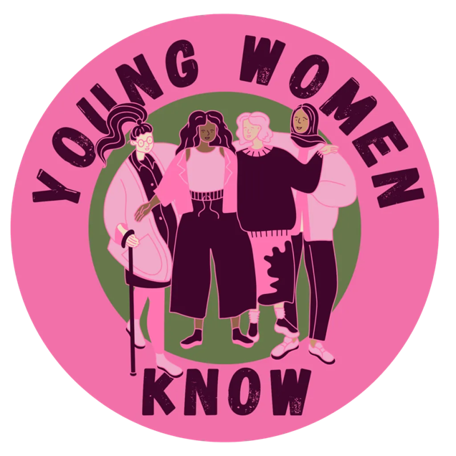

# Young Women Know

[Young Women Know](https://www.youngwomenscot.org/young-women-know) is a partnership programme between The Young Women’s Movement and NSPCC Scotland. It was set up to work with young women aged 16-18 living in different local authority areas to create toolkits to support young people in their understanding of healthy relationships, consent and safe spaces.

In partnership with Dundee City Council, Perth and Kinross Council and Angus Council, we worked with young women aged 16-18 to create resources around healthy relationships, safe spaces and consent. The three groups of young women called themselves: Brave Lassies Blether (Angus Council); Oor Fierce Girls (Dundee City Council); and Bold Girls Ken (Perth and Kinross Council).

## Teenage domestic abuse

The Young Women Know programme was created in response to the rising levels of violence experienced by girls and young women in teenage relationships. Research from the University of Bristol and the NSPCC suggests that 25% of girls aged 13-17 have experienced the use of physical force (pushing, slapping, hitting or being held down) in a relationship; more severe physical force (punching, strangling, being beaten up or being hit with an object) had been experienced by 11% of girls and 4% of boys.[1] Research also shows that online platforms and digital technology have potentially exacerbated the monitoring, control and surveillance of young women, often by young men, which has a significant impact on their health and wellbeing.[2]

Through our own research with Scottish Women’s Aid, we discovered that [over a third of young women aged 16-25 in Scotland had been in an intimate relationship with someone who was abusive or harmed them physically or emotionally](https://www.youngwomenscot.org/research-reports/the-rise-report/), and nearly three quarters knew someone who had.[3] Teenage relationship abuse is not a term that is defined by the Domestic Abuse (Prevention) (Scotland) Act 2021, or elsewhere in law, but if the victim and perpetrator is at least 16 years old abuse in their relationship will come under the statutory definition of domestic abuse as set out in the 2021 Act. This omits girls under 16 who might also be experiencing domestic violence in their teenage relationships.

At The Young Women’s Movement we believe more work needs to be done to raise awareness the prevalence of teenage domestic abuse and how to prevent peer-on-peer domestic abuse and violence from happening in the first place. Through our research, campaigns and programmes we work closely with young women aged 16-30 to empower their voices and ask them what change they would like to see to tackle violence against women and girls.

## Bold Girls Ken what consent is, but do you?

Bold Girls Ken is a youth-led campaign on consent, led by young women aged 16-18 in Perth and Kinross. The group discussed the importance of having conversations about sex and relationships, even if it can feel awkward or uncomfortable. Their resources focused on giving realistic and appropriate information about consent, to ensure young people explicitly know what consent looks like in everyday life.

Bold Girls Ken wanted their peers to know that:

* Consent is actively saying yes – with both your body and your language. It is enthusiastic and both partners should understand what they are consenting to;
* Consent can be withdrawn at any time and you should not feel pressured into consenting into anything that makes you feel uncomfortable;
* It is important to have good communication between partners to ensure everyone is consenting.
* Someone can be incapable of consenting because of the effect of alcohol, drugs or other substances. If you are unsure whether someone is consenting or not, you should stop immediately.

*“Consent should be enthusiastic, informed and ongoing!”* – Bold Girls Ken group.

The toolkit and resources on consent can be found on our [website](https://www.youngwomenscot.org/resources/young-women-know-consent/).

## Brave Lassies Blether about services

Brave Lassies Blether is a youth-led campaign on how to safely access services as a young person, led by young women aged 16-18 based in Angus. The group focused their campaign on healthy relationships and how young people can access a range of support services if they wish to speak to an appropriate adult. They wanted to digitally connect with young people so they created TikTok videos with organisations such as Hear Me Counselling, Sandyford, Childline and Rape Crisis Scotland, to explain how to access their service and how they approach working with young people in distress.

New technologies are typically central as a means by which young women communicate with their peers, and this is often used against them, for example, to keep surveillance of where they are and what they are doing and by monitoring their social media accounts. It was important for the young women to reclaim this space and disseminate information amongst their peers about how to remain safe, both online and in their teenage relationships.

The group wanted other young women to know:

* they have a safe place to talk about issues they are having by signposting them to relevant organisations and helplines;
* their experiences are not what will define them as an individual;
* there is someone ready to listen at the other end of the phone whenever they need it;
* they don’t have to struggle alone.

*“We wanted women to know that we understand speaking up is hard and that they will be supported the whole way. We wanted women to feel brave and empowered to speak up.”*   
 – Naeve Townsley, member of Brave Lassies Blether.

The videos on how to access services can be found on our [website](https://www.youngwomenscot.org/our-programmes/young-women-know/).

## Oor Fierce Girls want safe spaces

[Oor Fierce Girls](https://www.youngwomenscot.org/resources/oor-fierce-girls/) is a youth-led campaign on how to create safe spaces for young people in distress, led by young women aged 16-18 based in Dundee. The group developed resources to address peer sexual abuse, raise awareness of what healthy relationships should look and feel like, and how young people can access advice or support if required.

Oor Fierce Girls want other young women to know that they deserve to be safe, happy and healthy in their teenage relationships. It is important that we all know how we can best support young people to achieve this – whether that is by starting the conversation or by creating a safe space for young people to talk about anything that may be on their mind.

These resources detailed how to create a physical and online safe space where young people can find support for issues around unhealthy relationships, sexual harassment and peer-on-peer sexual abuse. Alongside launching a [video](https://www.youngwomenscot.org/resources/oor-fierce-girls/), the group developed a poster which was used as part of a bus stop ad campaign during 16 Days of Activism across Dundee. Their slogan read "*everyone deserves to have a space where they are safe, listened to and believed*.”

*“Conversations around healthy relationships and creating a safe space are absolutely crucial. We owe it to the young people in our lives to help them understand how they deserve to be treated, and to provide them with a safe space to talk about their relationships.”*

– Ashley Henderson, member of Oor Fierce Girls

The toolkit and resources on safe spaces can be found on our [website](https://www.youngwomenscot.org/resources/oor-fierce-girls/).

## Young Women Know in the Scottish Parliament

A huge milestone of their campaign so far has been presenting to the Education, Children and Young People’s Committee at the Scottish Parliament in November 2023. Bold Girls Ken and Brave Lassies Blether came together to present their work to the Parliament and inform the committee of what they thought would help other young people in schools to learn more about healthy relationships and consent.

The group discussed their experiences of the current Relationships, Sexual Health and Parenthood (RSHP) curriculum, highlighting that “there was a lack of consistency, even across schools, in which external partners come in and what is taught about healthy relationships and consent.” By offering evidence to the committee, the young women were able to advocate and discuss their own authentic experience of what they are being taught at school and offer insightful recommendations as to how they think young people should be included in this type of work. It was suggested by the group that young people should be able to feed into what RSHP lessons are taught and these lessons should be relevant, concise and available to all students across Scotland.

Presenting their work on healthy relationships, consent and safe spaces to MSPs in the Scottish Parliament has boosted the young women’s confidence and inspired them to advocate for the needs and rights of other young women and girls across Scotland. Our seven National Champions are now distributing the resources in schools and youth groups to ensure all young people feel able to start conversations around healthy relationships, safe spaces, consent and where to go if they need professional services and support.

# Conclusion

***“Women’s voices matter. What we have to say matters.” – Young Women Know Champion***

The Young Women Know programme highlights the importance of youthwork and working closely with young people to tackle violence against women and girls across Scotland. It also highlights the importance of elevating young people’s voices and experiences in spaces where decisions are made that seek to address the endemic nature of gender-based violence across Scotland.

At The Young Women’s Movement, we believe the Scottish Government should do more to make sure that **girls and young women from all backgrounds and identities are listened to and taken seriously** when decisions are made, particularly in relation to tackling violence against women and girls, including **ensuring participation with young people**, **investing in youth work** and **protecting it from budget cuts**. At The Young Women’s Movement, we will continue to empower young women’s voices to make gender equality a reality in Scotland.

# For further information

Contact: Dr Rebecca Mason, Research and Policy Lead, The Young Women’s Movement  
Email: [rebecca@youngwomenscot.org](mailto:rebecca@youngwomenscot.org)

# About us

The Young Women’s Movement is Scotland’s national organisation for young women’s leadership and rights. For over 100 years we have valued the power, and recognised the necessity, of working both intersectionally and intergenerationally to achieve change and imagine a better future for young women and girls across Scotland. Young women, girls and people of marginalised genders who recognise themselves within this movement are at the heart of everything we do by participating, co-designing and leading our research, programmes and campaigns.

1. NSPCC and the University of Bristol (2009), [Partner exploitation and violence in teenage intimate relationships.](https://www.researchgate.net/publication/265245739_Partner_Exploitation_and_Violence_in_Teenage_Intimate_Relationships)
2. Rojan Afrouz and Sevi Vassos, ‘Adolescents’ Experiences of Cyber-Dating Abuse and the Pattern of Abuse Through Technology: A Scoping Review,’ *Trauma Violence Abuse*, 25(4), (2024), pp. 2814-2828. doi: 10.1177/15248380241227457. 
3. Scottish Women’s Aid and The Young Women’s Movement (2021), [The Rise Report: Supporting young women facing abuse in their relationships.](https://www.youngwomenscot.org/wp-content/uploads/2024/05/The-Rise-Report-22.pdf) 