Young Women Lead 2024: Young Women’s Democratic Wellbeing in Scotland

Democratic wellbeing encompasses the ‘voice’ we have in public life and decisions that affect us. It is made up of the ways we are able to have this voice and how our voice is meaningfully heard and used by people in power. The term ‘democratic wellbeing’ was coined by Carnegie UK in 2022. [According to Carnegie UK](https://carnegieuktrust.org.uk/publications/gdwe-a-spotlight-on-democratic-wellbeing/), democratic wellbeing is an intrinsic aspect of collective wellbeing, which means to “look at personal wellbeing, the wellbeing of our local community, and the wellbeing of society as a whole”.

**Young women want to see their democratic wellbeing addressed and improved in Scotland. Young Women Leaders told us that they want politicians and decision-makers to:**

* Meaningfully consult with young women about their wants and needs before making decisions for and about them, including providing incentivised participation mechanisms for those who would not ordinarily engage in politics;
* Meet young women where they are at in their communities, engaging with them in an accessible way that meets their needs;
* Prioritise a culture that centres digital wellbeing, ensuring that young women feel safe online and able to access and benefit from engaging in digital spaces.

The findings of Young Women Lead 2024 have influenced The Young Women’s Movement’s annual Status of Young Women in Scotland survey (SYWS24) which will focus on young women’s rights in Scotland and considers some of the themes highlighted by the 2024 Young Women Leaders.

This report and its concluding recommendations for politicians and decision-makers in Scotland will be accompanied by a parliamentary briefing, delivering recommendations to the Scottish Parliament on how they can best support young women’s democratic wellbeing, and their continued engagement with the Gender Sensitive Audit Advisory Group in the Scottish Parliament.

Key Recommendations

**Trust in Society**

* Meaningfully consult with young women about their wants and needs before making decisions for and about them;
* Develop more accessible mechanisms for young women to engage with elected representatives who should make a concerted effort to engage young women and learn about the actual issues that affect them;
* Consider different accessibility needs and take appropriate actions to mitigate the differences between rural and urban communities. Young women’s ability to participate in spaces where change is made should not depend on where they live.

**Participatory Democracy**

* Provide more primary and secondary education on what democracy is and how to practically participate in democratic processes, for example speaking to MSPs, setting up or signing petitions, standing for election for Scottish Youth Parliament, starting a campaign on issues that matter to young women;
* Enhance methods of engagement: organisations, decision-makers, and elected representatives need to meet young women where they are at, in communities, engaging with them in accessible ways that work for them, providing incentives for engagement;
* Embed meaningful inclusive participation methods that lead to clear actions with accountability mechanisms to ensure transparent follow-through.

**Online Behaviours**

* Equip young women with the skills and knowledge to develop a critical understanding of Artificial Intelligence (AI), in order to help shape it;
* Work to provide affordable, high-speed internet access across Scotland, especially in rural and under-served areas;
* Streamline education surrounding critical thinking and how to be aware of misinformation online, for people of all ages. Prioritise inclusivity through universal digital access and digital skills education for all;
* Enable young women to use digital spaces in ways that actively supports their wellbeing, instead of it being harmful towards the wellbeing of themselves and others. A culture of care must be extended to online spaces;
* Improve safeguarding mechanisms for young women on public platforms from hate speech, misogynistic harassment, grooming, etc. and improve accountability mechanisms and procedures to report a complaint or cybercrime;

**Gender Sensitive Audit**

* Ensure that the findings of the Gender Sensitive Audit are embedded in parliamentary processes and that there is a clear action plan in place to implement such findings, to ensure transparency and accountability.

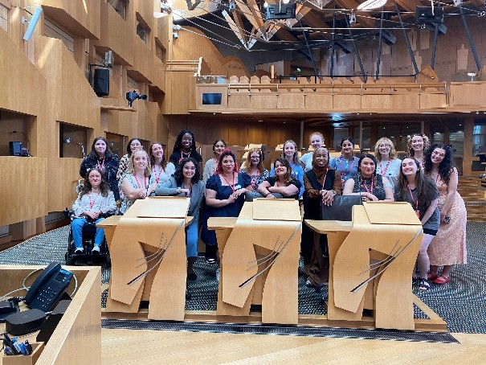

Contents

Foreword 5

Introduction 6

What is ‘Democratic Wellbeing’? 6

Trust in Society 11

Education 11

Healthcare 11

Politics 12

Justice 12

Digital 12

Differences Between Spaces 13

Threats to Democracy 13

Accountability 14

Recommendations: 15

Participatory Democracy 15

Access to Participation 16

Value of Participation 17

Recommendations 17

Online Behaviours 19

Fake News 19

Critical Thinking 20

Access to Information 20

Digital Wellbeing 21

Artificial Intelligence (AI) 22

Recommendations: 23

Gender Sensitive Audit 25

Recommendations 25

Comparison to Carnegie UK’s Research 26

Conclusions and Next Steps 28

Acknowledgements 30

Glossary 31

Foreword

**By Rosie McCann, Young Women Lead 2024**

Prior to Young Women Lead, I had not given much consideration to the concept of democratic wellbeing. I mistakenly believed it was a concern primarily for the wealthy, the powerful, and the activists. However, my involvement in the project made me realise the crucial role democratic wellbeing plays in ensuring that young women’s voices are included in decision-making processes. Without women at the table, there is a risk of being overlooked or ignored. Initially, I sought research experience, but as I became more engaged, my commitment to advocating for the wellbeing of young women in Scotland deepened. The project exposed me to the unique challenges they face, sparking a passion for making a meaningful impact in society.

In exploring democratic wellbeing, I have realised the vital importance of amplifying the voices of young women and marginalised genders in our societal frameworks and processes. From a personal perspective, being a woman has allowed me to observe the impact of the patriarchy on women and their ability to express themselves. At the time of #MeToo, I witnessed a historical moment where women courageously fought for justice. Since then, I have come to understand that the patriarchy seeks to silence female voices, leading women to seek support from each other and their broader network due to ongoing, systemic failures.

As a member, I observed that Young Women Lead consciously amplify voices from diverse backgrounds, not just those representing mainstream perspectives. To foster the democratic wellbeing of young women, it is crucial to introduce measures early on, allowing girls to form their own opinions on societal issues. By encompassing an age range of 16 to 30, Young Women Lead has effectively incorporated perspectives from multiple generations. Intersectionality has also been achieved by including women of colour, queer women, disabled women and those of marginalised genders.

# Introduction

Young Women Lead (YWL) began in 2017 as a leadership programme for women and non-binary[1] people aged 16-30 years old. It was established to provide participants with a unique and exciting safe space to share their experiences and work together to create real, tangible change. The focus of YWL24 is: ‘Young Women’s Democratic Wellbeing in Scotland’. This national programme has included partnership work with the Participation and Communities Team at the Scottish Parliament.

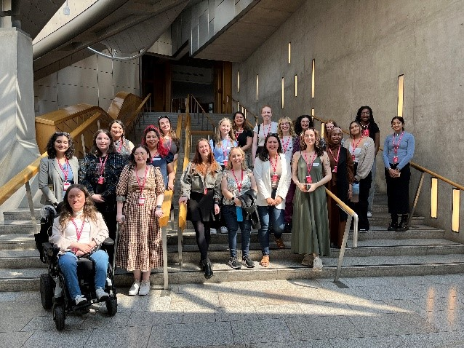

## What is ‘Democratic Wellbeing’?

Democratic wellbeing encompasses the ‘voice’ we have in public life and decisions that affect us. It is made up of the ways we are able to have this voice and how our voice is meaningfully heard and used by people in power. The term ‘democratic wellbeing’ was coined by [Carnegie UK](https://carnegieuktrust.org.uk/) in 2022:

“Democratic wellbeing is a vital part of collective wellbeing. We should all have a voice in decisions that affect us, with greater power given to individuals and communities.”

[Carnegie UK, ‘[GDWe: A spotlight on democratic wellbeing](https://carnegieuktrust.org.uk/publications/gdwe-a-spotlight-on-democratic-wellbeing/)', 2022, 20]

[Carnegie UK](https://carnegieuktrust.org.uk/), an independent charitable foundation whose purpose is to achieve better wellbeing for people in the UK, says that we must have ‘democratic wellbeing’ in order to live well together. Their research, however, did not focus on the democratic wellbeing of young women in Scotland specifically.

We know that [women are underrepresented in politics in Scotland](https://www.engender.org.uk/content/publications/Womens-Equal-Representation-in-Scotland.pdf) - from councillors in local government to Members of the Scottish Parliament. Unfortunately, we lack access to robust data on other protected characteristics of our elected representatives, but we do know that underrepresentation is more acute for specific groups of women, including disabled women, racialised women, trans[2] women, and women on low incomes, to name a few. This lack of visibility can mean that young women, particularly those from marginalised[3] communities, do not feel encouraged to get involved in politics at various levels, which can have a detrimental impact on their democratic wellbeing.

Young women increasingly live and grow up in a digital age. What we see online can have a huge impact on democracy because it can affect the way we think and talk about different issues that affect our lives. However, not everything we see online is always true or factual.

Having ‘democratic wellbeing’ for young women and girls means they can:

* Live complete and fulfilling lives (both online and offline);
* Have equal opportunities, rights, and resources to thrive and hold decision-makers accountable;
* Get involved in democracy (for example, through voting or standing in local or national elections);
* Trust that they are fully represented in all aspects of life, from local and national politics to education and the justice system.

Using [Carnegie UK’s research](https://carnegieuktrust.org.uk/publications/gdwe-a-spotlight-on-democratic-wellbeing/) on how we can measure ‘democratic wellbeing’, Young Women Lead 2024 has focused on democratic wellbeing for young women in Scotland through three key themes:

* **Trust in society:** do young women feel like they are being listened to?
* **Participatory democracy:** can young women get involved in democracy? If so, how?
* **Online behaviours:** how do young women use digital technology? Are they safe online?

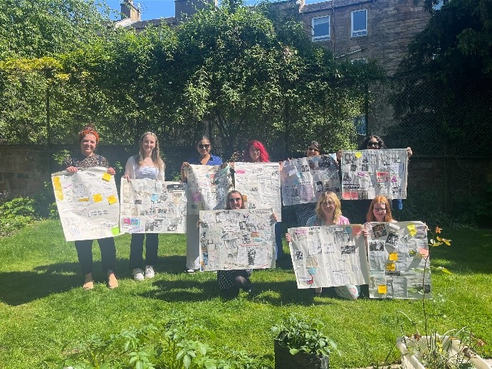 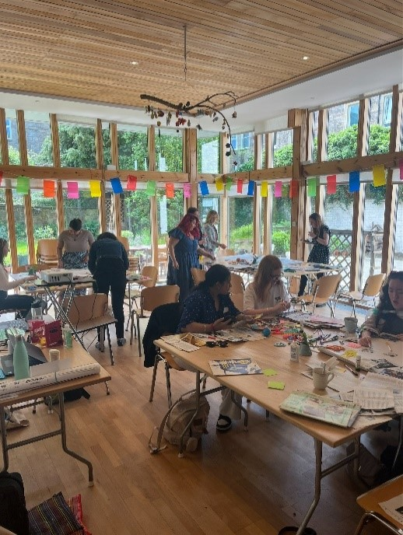

The results of discussions with a group of 17 young women and people of marginalised genders[4] in Scotland, aged 16-30, are laid out in this report, with a set of concluding recommendations on how democratic wellbeing can be improved for young women in Scotland today.

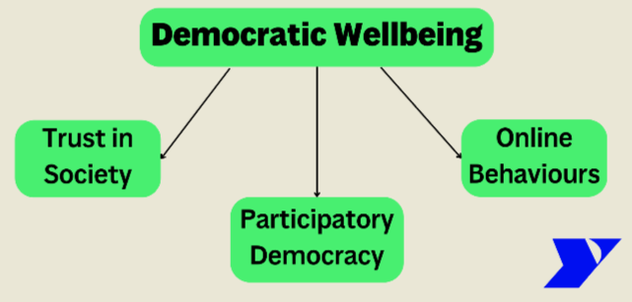

The group used various magazines for collaging, including feminist magazines from the 1970s, leading to conversations about how little some participants felt they learnt about feminism at school, as it is often presented as a newer concept, and not something that has been debated for decades. The group also reflected on both how much, and how little, has changed for women since the magazines were published, noticing many of the same themes coming up, such as violence against women and girls, racism, and patriarchal expectations[5] about women’s roles in society. They were able to celebrate some wins during their discussions, such as the increasing representation of women in politics and public life, whilst recognising that there is still a long way to go.

After creating their collages for each topic, the Young Women Leaders spent a full day unpacking each of the three themes, discussing their meaning, what could be done for young women in spaces where power is held, and deciding what they wanted politicians and decision-makers to know about their engagement with these themes in public life. Overall, the widespread conversations had by the Young Women Leaders on the three themes demonstrate the need for a whole-society approach to enable young women to have democratic wellbeing.

**The group discussed what each of the key themes outlined meant to them, resulting in the following collages for each theme:**

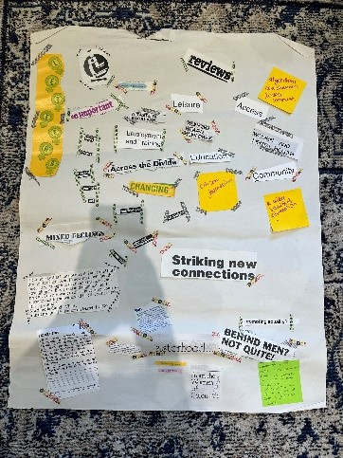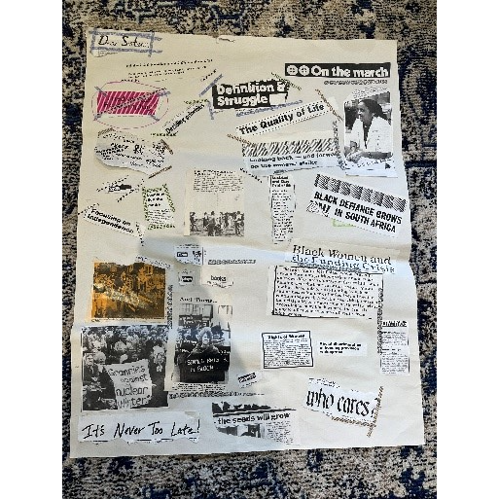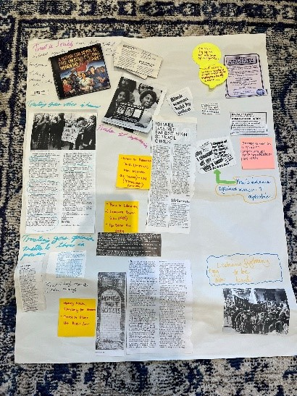

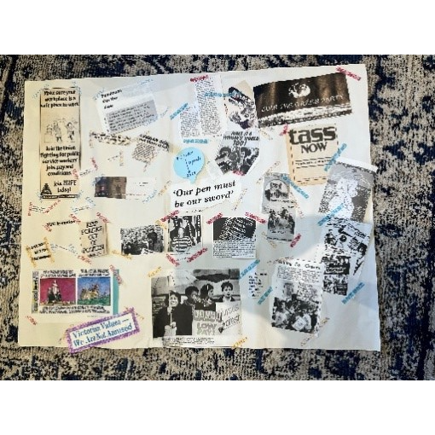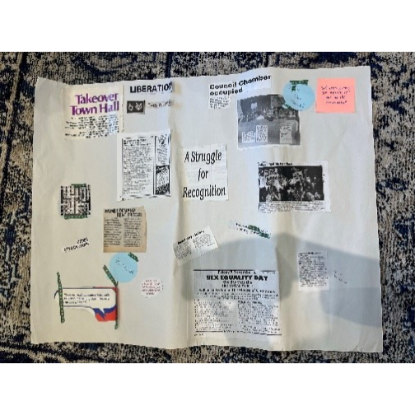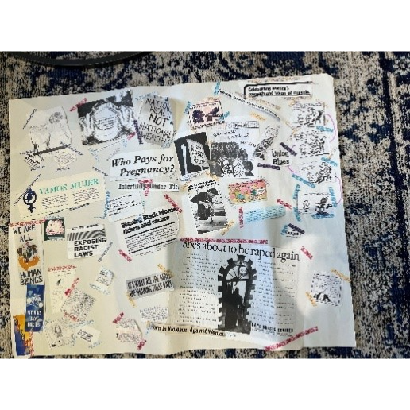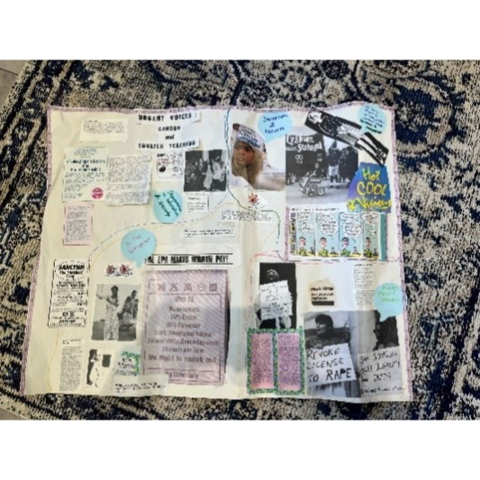 .   
 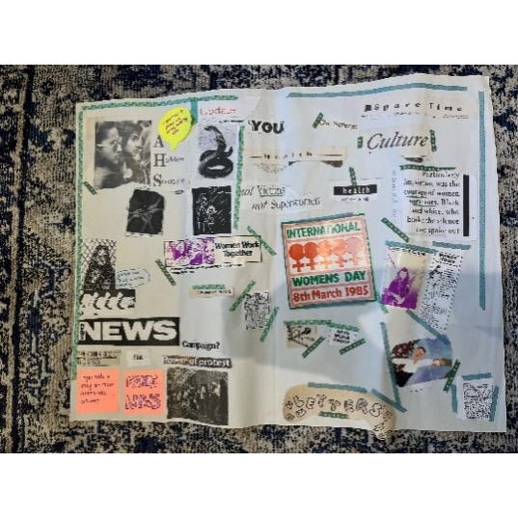

# Trust in Society

Young Women Leaders noted that patriarchal expectations about ‘how to be a woman’ contribute to a loss of trust in society, as well as structural barriers within some institutions that create a loss of trust for specific marginalised groups. They also talked about the stigmatisation of young women activists, limitations surrounding higher education and which positions women hold in society, lack of education surrounding topics like feminism, safety in society, and the sexualisation of women’s bodies.

In terms of where there were higher levels of trust, participants talked about trust in other women and in community groups that they belong to, more so than in wider societal structures. Young women remarked that they found it difficult to feel safe in society, regardless of their backgrounds. Participants discussed a lack of trust in men, men-led spaces, and the wider system where gendered dynamics are upheld, as obstacles to their trust in society.

Discussions centred on various spaces and groups within society and why young women’s trust varies in these spaces.

### Education

Young Women Leaders found that, though change didn’t always happen in education, there were always efforts to hear their thoughts and feedback via surveys/student council. Participants discussed how they gain their information in educational spaces, who gets to choose what they learn, and how who is in the room with them impacts the perspective they are learning about. Higher education institutions were perceived as having more say in what they could change than secondary schools. However, they also noted that there are things they would be unlikely to trust higher education institutions with, such as reporting gender-based violence, due to a lack of support mechanisms and trauma-informed[6] practice.

### Healthcare

Healthcare is a priority for young women. Young Women Leaders acknowledged that it is “really hard” to be heard in healthcare settings as young women and that there is often the need to self-advocate. It can be difficult to trust in the healthcare system as information is not always stable, guidelines change quickly, and doctors do not seem to have much control over what they can actually change for their patients; it does not feel as though patient feedback has anywhere to go as the NHS is so under-resourced. Participants noted seeing other young women on apps like TikTok talking about medical bias: doctors making decisions for you based on what you look like, for example, assuming any issues are to do with body weight/existing healthcare issues/ethnicity/sexuality/reproductive health, which creates a lack of trust. Young Women Leaders noted that there are also many healthcare practitioners who want to help but often don’t have resources/training to change anything.

### Politics

Bigger systems, like the Government, do not seem to have a sufficient feedback loop for people to express their opinions or see active steps to make real change. Participants from more urban areas noted that they often do not hear from elected representatives until it is time to vote – they “never see them in real life, only on election leaflets”. However, those in rural areas noted that elected officials are more frequently visible in their communities. Both groups agreed that they would value elected representatives making more efforts to connect with young women in their communities, using digital presence as well as physical presence in community spaces where they can effectively and safely communicate with young women. They argued that the lack of active involvement in community means that they often do not represent issues accurately and instead make assumptions based on their own ‘echo chambers’[7], rather than engaging with local people and asking where the problems lie.

### Justice

Young Women Leaders discussed the criminal justice system and noted their uncertainty/discomfort on whether they would report issues to the police. They felt that some issues wouldn't be dealt with and had concerns that those in power might make harmful assumptions about young women themselves, including racial profiling. Some young women felt that the justice system often does not support young women in general, including those who work within these systems. Again, there were differences between rural and urban communities and the presence and perception of law enforcement. This perception again seemed to be better where law enforcement was actively involved in the community.

### Digital

Young Women Leaders talked about the ways the ‘digital’ space pervades most of the other societal spaces they discussed, and the huge influence it has on their generation, both positively and negatively. They discussed inclusivity and community in spaces that they themselves inhabit, though were aware that these spaces can be ‘echo chambers’ and that there are sides of the internet they do not inhabit, where they would not feel as safe (noting, for example, ‘incel’ culture[8]).

### Differences Between Spaces

Bigger systems like Government and the justice system were seen as having too many structures for any meaningful change to happen; participants also noted healthcare as “too big a system” to be able to have an impact on. The group concluded that they often feel it is easier to trust that their voice is heard in smaller spaces, such as community spaces or groups like Young Women Lead itself, where people have common views/experiences and choose to be there.

However, the group also felt that they would be more likely to trust smaller scale spaces, such as community and youth work spaces, women’s running clubs, book clubs, etc., and view them as a place where change can happen, even when people do not always share these common views, if there is an active drive for inclusion and listening. This is because trust, for the Young Women Leaders, can be fostered in places with diverse views where there is a will to include, listen to, and make decisions in the best interests of, young women. They also noted that there are few of these spaces for young women specifically, as community spaces generally focus on children or older people. Participants also felt that opportunities look different for rural, in comparison to urban, communities.

### Threats to Democracy

Participants also discussed the context in which they do or do not have trust in societal systems by looking at potential threats to democracy and accountability mechanisms. They found it theoretically easier to discuss potential threats, talking about wealthier people having more power, the media being owned by a small group of men, power being centralised, both in a UK, (with Scotland, for example, being out-voted in the Brexit referendum) and Scottish context (with the Highlands being far removed from the Central Belt). They felt that the lack of accessible opportunities to get involved, make decisions, or challenge the system, outside of voting, leads to a deep sense of mistrust.

The group also discussed how decision makers tend not to meet young women where they are at, both physically and in terms of their knowledge and understanding. They also noted that it should be the responsibility of those in power to know how to articulate their thoughts without using exclusionary language or jargon. They discussed the possibility of elected representatives making reasonable adjustments so that what they are discussing is suitable for all people they represent, regardless of their level of education, their age, their gender, their English proficiency, and so on. This can be particularly dangerous for young women who are already more likely to have imposter syndrome and feel less confident seeing political spaces as places they belong, and are welcome in. They also discussed:

* Registering to vote and bureaucratic accessibility issues, for example, with the speed of the General Election coming around and being rushed to register to vote;
* General lack of knowledge/mainstream education means that fake news[9] can shape/distort people’s views and also lead people to feel that political spaces are not ‘for’ them;
* Lack of representation: who will listen to and represent you?
* Issues surrounding classism, extremism, misogyny, and misinformation online;
* Two-party system (voting against instead of for, discussions around the United States as a comparative example);
* People being scared to vote or people not voting at all due to disillusionment and belief that 'nothing will change';
* The difference between what people who are making decisions think the problems are, compared to the actual problems people are facing.

### Accountability

A perceived lack of accountability mechanisms for those in power means that there does not appear to be any incentive for them to advocate for young women’s issues and no counter incentive for them to be held accountable when they do not advocate for these issues. Participants discussed ‘cancel culture’, arguing that, though sometimes people in power do get vilified in the media, this is often only temporary and disproportionately amplified on social media sites. They argued that sometimes accountability appears performative and people in power don’t experience appropriate consequences for negative actions or behaviors– i.e. someone is identified as having done a ‘bad thing’, but it does not impact their career or access to power. The fact that less women are in power impacts the way young women see people/men in power, not expecting them to advocate for their rights because they simply do not identify with them or feel represented by them.

The Young Women Leaders were asked to rank who they felt was most to least accountable to young women in Scotland, out of various people in positions of power. Friends, parents and carers were ranked the most accountable, with MPs and the police equally the least accountable, closely followed by MSPs and local councillors. MSPs were voted slightly more accountable than MPs. The Young Women Leaders argued that having the ability to have direct contact with a space/individual creates an increased sense of trust. Where there are clear biases or lack of accountability mechanisms, there is decreased trust.

### Recommendations:

* Meaningfully consult with young women about their wants and needs before making decisions for and about them;
* Develop more accessible mechanisms for young women to engage with elected representatives who should make a concerted effort to engage young women and learn about the actual issues that affect them;
* Implement deliberate accountability mechanisms to ensure work is followed through and effectively evaluated;
* Increase political representation of young women from all backgrounds (particularly those from marginalised communities) through an active drive by political parties;
* Intentionally increase the presence of politicians and decision-makers within community and digital spaces inhabited by young women in order to foster young women’s trust in them;
* Consider different accessibility needs and take appropriate actions to mitigate the differences between rural and urban communities. Young women’s ability to participate in spaces where change is made should not depend on where they live.

‘When we create a space for young women from all backgrounds to share, we gain deeper insights into solutions that benefit a wider community. As women, we care for our communities, not just ourselves’ - Natalia Uribe

# Participatory Democracy

Participatory democracy was a more complex topic for the Young Women Leaders to reflect on, though words they associated with this concept included:

* Human rights
* Love
* Rebellion
* Feminism
* Inclusion
* Recognition of our own places in society
* Representation
* Social media
* Activism
* Local and national elections

Participants felt that protests seem to be very common in the current climate and that different types of protest exist. They discussed women’s approach to protesting and believed that women are often more peaceful by using the arts to speak, advocate, and assemble, and the importance of having a safe space for debating or discussing difficult issues.

Working with key stakeholders in young women’s political participation (the Scottish Parliament Participation Team, ElectHer, and Scottish Youth Parliament), the Young Women Leaders discussed the different ways young women can engage in politics, and the barriers to their participation. Their key reflections surrounded: accessibility, intersectionality[10], and the perceived value of engagement.

### Access to Participation

* Politics does not currently feel accessible to many young women;
* Politicians do not communicate with young women about the issues that matter to and impact them, in accessible and engaging ways;
* Participation mechanisms lack intersectional considerations and reasonable adjustments for young women from marginalised communities, including asylum seekers and refugee women, disabled women and racialised women, to name a few;
* Politicians and decision-makers need to understand which groups are not currently being consulted, reached, and/or represented in policies and legislation. Who is impacted but not often engaged with? This includes, but is not limited to:
* Low-income households;
* Immigrant backgrounds and racialised communities[11];
* Care-experienced young people;
* Young parents;
* Religious minorities;
* People with disabilities, additional support needs, and young carers;
* Financial and time barriers to standing for election – women's lives being dictated by the concept of timescales;
* Lack of women's employment rights in elected roles, such as lack of/limited access to maternity leave.

### Value of Participation

* Young women often feel like their voice is not heard and that voting is not worthwhile;
* Lack of clarity and transparency is off-putting: what does the Scottish Government and Scottish Parliament do with reports and recommendations?
* Fear and intimidation prevent young people from getting involved in politics; lack of trust in political systems and fear of being in the public eye due to intense public and media scrutiny are huge barriers;
* Young women need continuous and sustainable engagement from elected representatives, especially those who aren’t already interested/engaged. Elected representatives should clearly demonstrate the results of their engagement;
* Young women value community outreach and engagement, with politicians meeting them where they are at and meaningfully listening to their experiences and concerns.

### Recommendations

* Provide more primary and secondary education on what democracy is and how to practically participate in democratic processes, for example speaking to MSPs, setting up or signing petitions, standing for election for Scottish Youth Parliament, starting a campaign on issues that matter to young women;
* Education could, for example, happen through video content from elected representatives explaining the process of policymaking and introducing proposed Bills to the Scottish Parliament;
* Conduct further research on how young women want to be engaged with, both on and offline;
* Stop politicising inclusion[12]: be actively and deliberately inclusive, as opposed to performatively inclusive[13], to reinforce a sense of democratic wellbeing amongst young women;
* Provide safe and brave spaces[14] for open discussion and learning, understanding that certain groups may struggle to provide critical feedback due to precarious living situations, such as refugees and asylum seekers. Safe and brave spaces are essential for inclusive conversations with those who have diverse perspectives to be productive. These spaces must prioritise a culture of care[15], ensuring optional anonymity and confidentiality to protect those using the space;
* Reflect on what makes a safe and brave space and decision-makers' positionality – consider who should be facilitating these spaces for open discussions to be productive and unbiased;
* Provide more interactive campaigns, opportunities and projects like Young Women Lead to enable meaningful youth engagement, and ensure these are locally and accessible advertised, including through printed posters, not just online;
* Enhance methods of engagement: organisations, decision-makers and elected representatives need to meet young women where they are at, in communities, engaging with them in accessible ways that work for them, providing incentives for engagement;
  + Provide easy-read versions of all engagement materials and outputs to make sure the public know and understand what their participation leads to;
  + Consider Deaf and Blind young people, including providing BSL interpretation as standard;
  + Instead of survey work as the default, engage with young women in-person and have designated time to fill out any surveys at the end of an in-person session. In-person engagement is preferred (or video call) and participants said that they are more likely to fill out a survey if they’ve done something in-person with that organisation/group beforehand;
  + Meet with young women to discuss issues that impact them, for example to discuss sensitive topics like period health or maternity rights in workplace;
  + Young women want to know who their elected representatives are and want to see them in their communities, not just on a campaign poster during an election period;
* Provide incentives for participation, for example, where young women are sharing their lived experiences;
* This does not always have to be financial, for example YoungScot points or vouchers;
* Provide mentorship opportunities to support young women with the knowledge on how to enter, and feel safe to enter, political spaces and other positions of power, and participate in public life;
* Create specific networks, in safe spaces that prioritise a culture of care, with facilitators who the young women can relate to and who support them to build confidence and leadership skills;
* Embed meaningful inclusive participation methods that lead to clear actions with accountability mechanisms to ensure transparent follow-through.

# Online Behaviours

Young Women Leaders widely discussed the theme of online behaviours. They discussed the value and speed of social media for accessing information/art/communities/jobs/education and making connections, and the different ways they are used by different age groups. Though they noted the value of online communities from similar backgrounds or with similar viewpoints, they also discussed the idea of the ‘echo chamber’ and how this may get in the way of whether or not people are able to widen or challenge their views.

The group discussed the potential positive and negative impacts on mental health when engaging in online spaces. This included exposure to harassment, particularly for those involved in online activism but also the opportunities to hold people in power to accountability. They went on to discuss the value and dangers of online anonymity, the difficulty of differentiating fake news from real news, and the dangers posed to young women by algorithms[16] delivering more misogynistic[17] content to young men online. This content often upholds and perpetuates patriarchal expectations and standards.

### Fake News

Participants undertook an activity identifying real vs. fake news, noting that they can sometimes tell fake news by its use of graphics and misspellings. However, with the rise of AI and a lack of skill in strong critical thinking, young people often struggle to digest and interpret the news and often only absorb headlines and imagery. Participants discussed where young people are most likely to receive their news. Some found it surprising that [TikTok is the most used news source among 12-15-year-olds](https://www.ofcom.org.uk/media-use-and-attitudes/media-habits-children/children-and-parents-media-use-and-attitudes-report-2024/) (Ofcom, 2024), however, younger members of the group were not surprised. They noted that TikTok is the social media platform that is used most by young people, is often where they spend large portions of their time and is frequently where they find their role models.

Participants talked about the impact of fake news on trust in society. They commented that the prevalence of fake news means that people often don’t believe the things that they see, even when they are real. This can lead to conflict and dangerous narratives. They noted the need for laws to be updated, made clearer, and enforced to prevent misinformation quickly spreading online.

### Critical Thinking

Critical thinking skills were a core discussion point. Participants stated that they did not think that young women are always equipped with critical thinking when it comes to accessing their news/information online. Access to education has a huge impact on this; they argued that schools should support young women to build critical thinking skills, specifically in relation to what they see online. However, teachers also need to be better informed in order to provide young people with a solid level of understanding of digital spaces and their potential impacts. The group were concerned about the generational gap of digital literacy. Currently, Young Women Leaders feel like adults/teachers/parents and carers/decision-makers are not aware of how young people use digital spaces and of the many repercussions that this can have offline. Participants also noted that, depending on home environments and the frequency of open discussions/debates, these skills can often be developed at home.

### Access to Information

Young women often use the internet to access information that is either missed at school or is not catered towards young women’s educational needs, such as sex education. However, participants noted that information from online sources is often inaccurate or untrue, which poses dangers to young women. The Young Women Leaders discussed a loss of listening skills, as well as critical thinking skills, and the need to change the way we think and communicate with others. Generational gaps were discussed as being an issue for older people not understanding/listening to young people putting forward different views, and vice versa.

Participants discussed patriarchal expectations, often enabled and normalised in education, and how they contribute to young women asking fewer questions, being mansplained[18] to, or being prevented from forming and verbalising their own opinions. Debate can be a contentious topic for young women in particular, with members of the group noting that young women are often shut down and told to keep quiet. In the safe space of the group, the Young Women Leaders debated the pros and cons of young people getting their information online.

**Pros of gaining information online included:**

* Young women can access people with similar experiences who are able to provide them with a sense of belonging and community;
* Young women are able to access opportunities they would not otherwise, for both professional and personal development, through these communities, for example Young Women Lead and Elect Her;
* Young women are able to advocate for themselves a lot more than they could previously;
* Ease of access to services online to help with safety;
* More diverse role models online in whom young women can see themselves represented;
* People are able to use social media/online news outlets to debunk false rumours.

**Cons of gaining information online included:**

* Discussions often being dominated by men;
* Prevalence of fake news and lack of critical thinking skills to identify this;
* Algorithms boosting harmful content that can be dangerous for lots of different groups, including vulnerable men;
* Being very young in digital spaces can be difficult and prevent you from knowing what to believe;
* ‘Echo chambers’ can mean that you are unable to relate to or understand other people’s perspectives;
* The group were concerned about people getting ‘stuck’ in ‘echo chambers’, both amongst themselves, and for young men and boys, with the rise of misogynistic ‘incel’ culture online;
* Unattainable beauty standards online and pressure to conform to them;
* Information moves too quickly online and can damage attention spans;
* Young women influencers are more likely to receive backlash in online spaces than men.

### Digital Wellbeing

The Young Women Leaders discussed problems with social media addiction amongst young people and the need for preventative education in this area from a young age. They discussed the need for teachers and youth workers to understand young people’s usage levels of digital tools and to have the capacity to teach young women about digital wellbeing. Young Women Leaders were concerned about the impacts of social media addiction as well as issues that specifically impact young women’s wellbeing online, such as exposure to diet fads, body image expectations, and bullying. This can contribute to negative expectations on how young women ‘should’ look, think and feel, therefore impacting how they position themselves within society, who they trust and who they look to as role models.

The group emphasised the need for education about balance between their online and offline lives, to ensure young women are supported to access both the digital space and the outdoors in a streamlined and consistent way, for example, at school.

### Artificial Intelligence (AI)

When asked what Artificial Intelligence (AI) makes them think of, the Young Women Leaders discussed:

* Job displacement;
* Cheating on exams;
* ChatGPT;
* Pictures and images
* Tone check;
* Taking jobs;
* Taking over the world;
* Robots;
* Fake;
* Expansive;
* Ethical?
* Artificial creativity;
* Fake images;
* Not real;
* AI art;
* Makes life easier;
* Writing essays;
* Computer generated;
* Creating images;
* Job search

The Young Women Leaders had various perspectives on the increasing prevalence of AI in our lives, with some noting the dangers of AI having “too much control over our lives” (for example, automatically knowing our passwords) and others noting that AI has been involved in our lives on a large scale for a number of years, not just recently. We know that women are underrepresented in the digital technology sector in Scotland, [representing only 23.5% of the workforce](https://www.womenintech.co.uk/women-in-tech-in-scotland/). Participants noted that if more diverse people worked in AI, it would be less likely to be biased. The Young Women Leaders were very concerned about the concept of whether or not AI could ever be ethical/without bias and how this bias disproportionately impacts young women. One participant also stated that AI may be useful to help combat loneliness, for example for those living in rural areas.

### Recommendations:

* **Digital Wellbeing;**
* Support young women to know how to balance their usage of digital tools with their time spent offline;
* Enable young women to use digital spaces in ways that actively support their wellbeing, instead of it being potentially harmful towards the wellbeing of themselves and others. A culture of care must be extended to online spaces;
* Provide funding for projects that focus on young women’s digital wellbeing and allow young women to develop resources to support their wellbeing online.
* **Artificial Intelligence (AI);**
* Improve representation and inclusion of young women from all different backgrounds in design and development of AI tools to ensure these tools understand young women’s needs and are able to tackle gender bias;
* This could be done through collaborative platforms where young women can contribute ideas and feedback on AI projects, ensuring their voices are heard in the development process;
* Safeguard employment for those in careers at risk of being made redundant through use of AI, and support the upskilling of young women so that careers created by AI are accessible to more young women, who are currently [underrepresented in the tech sector](https://www.youngwomenscot.org/research-reports/young-women-code-2/);
* Equip young women with the skills and knowledge to develop a critical understanding of AI, in order to help shape it;
* Ensure ethical guidelines for AI tools and their development; guidelines should centre on inclusivity, security, and mechanisms to reduce bias to ensure users feel safe.
* **Digital skills and access;**
* Work to provide affordable, high-speed internet access across Scotland, especially in rural and under-served areas. When encouraging digitalisation, consider who can access digital spaces and tools, and what barriers prevent this access;
* Streamline education surrounding critical thinking and how to be aware of misinformation online, for people of all ages;
* Fund and implement programmes in all schools (including those in lower SIMDs[19]) and communities that teach young women essential digital skills;
* Continue to update and clarify laws regarding the spreading of misinformation online and provide better policing over reported accounts;
* Make information provided online easier to process and understand, for example avoid using jargon and provide summaries, visuals and statistics;
* Make sure people are informed about decisions and opportunities that are being advertised online, for example, by going to low-SIMD areas, where people might not have access to the internet, or by advertising information in community centres and public spaces;
* Implement evaluation processes to identify what young women are accessing online, what they need from the digital space, and what they do not currently gain from it, to see how the digital space could be better developed to suit young women’s needs;
* Ensure sources are attached to online articles so that people can fact-check opinions or statistics with ease;
* Prioritise inclusivity through universal [digital access and digital skills education](https://audit.scot/publications/tackling-digital-exclusion) across all schools, as some students are provided with laptops/tablets, whilst others are not;
* Encourage the creation and promotion of content that is relevant and engaging to young women, covering topics such as health, career development, education, and human rights;
* Teach the impacts and potential dangers of social media and digital platforms from an early age;
* Consider the environmental impacts of digital tools and the distinctly gendered impacts of climate change.
* **Online safety;**
* Improve safeguarding mechanisms for young women on public platforms from hate speech, misogynistic harassment, grooming, etc. and improve accountability mechanisms and procedures to report a complaint or cybercrime;
* Monitor, update and clarify cybersecurity laws and regulations surrounding the spreading of misinformation online and provide better policing over reported social media accounts;
* Increase public knowledge around provisions in the Online Safety Act (2023) and how young people might report a complaint or cybercrime that falls within its remit;
* Ensure age-appropriate content online, including the adverts shared with younger users, to facilitate young women’s safety in the digital space;
* Hold influencers accountable for hateful or harmful content, including, but not limited to, promotion of dangerous dieting content, which can contribute to negative expectations for young women;
* Host campaigns covering topics like cyberbullying, sextortion, and how to navigate social media safely as a young person;
* Provide readily accessible support services, such as counselling and legal advice, for young women who have experienced online abuse, hacking, deep-fakes[20], sextortion[21], image-based sexual abuse (‘revenge porn’[22]), etc.;
* Continue work, such as [Police Scotland’s upcoming project](https://www.gov.scot/publications/programme-government-2024-25-serving-scotland/), to develop targeted sextortion awareness campaigns ensuring the voices and experiences of young women are centred throughout;
* Increase and improve online safety training for teachers and practitioners who work with young women.

# Gender Sensitive Audit

The Young Women Leaders discussed the Scottish Parliament’s work on the Gender Sensitive[23] Audit. Their key observations surrounded the report’s lack of accessibility. Participants felt it was necessary to have clarity on the purpose of the [Gender Sensitive Audit](https://www.parliament.scot/-/media/files/spcb/gender-sensitive-audit.pdf) in accessible language and an accessible format. They suggested an ‘easy-read’ report to increase accessibility. The Young Women Leaders were keen to understand what happened with reports such as this one, who reads them, and how they are actioned. The Young Women Lead 2024 cohort are keen to engage with the GSA Advisory Group surrounding their recommendations for the work and have already fed their findings back to this group.

### Recommendations

* Experiment with different formats for reporting that consider various audiences;
* Visuals are helpful to understand, including word maps, graphs, colours, voiceovers, multimedia elements (such as young people talking to the camera), swipe-through images;
* Utilise ‘easy-read’ to help people understand and minimise jargon, however, where jargon is necessary, provide clear definitions;
* Develop a more accessible and clearly understandable title. Referring to the document as ‘A Parliament for All’ makes more sense than ‘Gender Sensitive Audit’ but also suggests that it is about more than just men and women and therefore could be misleading;
* Utilise storytelling: young women value seeing people who work in Parliament talking about their own career journeys into their professions;
* Fund and conduct further research implementing a more intersectional approach which ensures the experiences of people from marginalised communities and backgrounds are centred and celebrated;
* Engage with the public through community sessions that present the findings and recommendations of such reports;
* Engage with people on why they are not standing, or would never seek to stand, for election (for example, young women, trans, and non-binary people) in order to understand what needs to change;
* Ensure that the findings of the Gender Sensitive Audit are embedded in parliamentary processes and that there is a clear action plan in place to implement such findings, to ensure transparency and accountability.

# Comparison to Carnegie UK’s Research

Overall, according to Carnegie UK’s research, the democratic wellbeing score for young people in Scotland was lower than that for young people across the UK ([Carnegie UK, IPSOS, Life in the UK - Focus on Age, 2023)](https://d1ssu070pg2v9i.cloudfront.net/pex/carnegie_uk_trust/2023/11/12143741/Life_in_UK_Focus-on-Age-1.pdf). However, the age brackets used within this research were limiting, particularly within The Young Women’s Movement’s context of working with young people under the age of 30. Carnegie UK’s age bracket of 25 to 49 years-old is too wide a scope for us to fully understand young people’s perspectives. Carnegie UK also noted no gendered differences in ‘democratic wellbeing’ scores, but did not disaggregate their findings by gender and age together, so we do not have information on the democratic wellbeing score for young women specifically.

In [Carnegie UK’s 2022 research, GDWe: A spotlight on democratic wellbeing](https://carnegieuktrust.org.uk/publications/gdwe-a-spotlight-on-democratic-wellbeing/), 18 to 24-year-olds were the most likely age group to report that they didn’t know how well UK democracy functioned, and women reported being less likely than men to have an opinion on the state of UK democracy (GDWe, 2022: 7). Our Young Women Leaders discussed a general lack of understanding surrounding the functions of democracy in Scotland and the UK more generally. However, they consistently demonstrated that they did have opinions on the state of UK democracy – though it must be noted that Young Women Leaders are a self-selecting population, volunteering for this work as a project focusing on democracy.

In Carnegie UK’s research, when asked about the biggest current threat to democracy (GDWe, 2022: 8):

* 29% of 18 to 24-year-olds reported not knowing what the most significant threat to democracy was at present;
* For both 18 to 24 and 25 to 49-year-olds, loss of trust in Government came in their top 3 threats.

When asking our Young Women Leaders about threats to democracy, unlike almost a third of young people in Carnegie UK’s research, they came up with various potential current threats. Similarly to Carnegie’s research, however, they did note that loss of trust in political systems is a huge threat to democracy.

Carnegie reported “little difference between the responses from different ages, genders and social grades” (GDWe, 2022: 11) with regards to a lack of trust in the governmental bodies. When looking at trust in media, Carnegie UK found “high levels of distrust in media and social media but national statistics and public services in general were trusted sources for information.” (GDWe, 2022: 12). Again, there were differences in what sources people trusted by age and gender:

* 18 to 24-year-olds were more likely to report greater trust in the media (27% compared to a population rate of 18%) and social media (20% compared to a population rate of 8%);
* Men were more likely (21%) to have greater trust in media than women (16%) (GDWe, 2022: 13).

As noted in our report, the Young Women Leaders discussed young women’s use of social media as a news source, though there were different feelings about the frequency of this from those at opposite ends of our age range, suggesting a need for further disaggregation by age.

According to [Carnegie UK, IPSOS, Life in the UK Scotland, 2023,](https://d1ssu070pg2v9i.cloudfront.net/pex/carnegie_uk_trust/2023/11/15124001/Life_in_UK_Scotland_Report.pdf) report:

* Most people in Scotland (79% in Scotland in comparison to 73% in the UK) feel that they are unable to influence UK Government;
* 60% feel that they are unable to influence Scottish Government;
* 51% feel that they are unable to influence local decision making.

Comparing Scottish respondents to UK respondents:

* A higher proportion of people in Scotland (60%) than the UK (52%) did not trust the UK Government;
* Over a third of participants in Scotland (39%) also reported low levels of trust in the Scottish Government (18);
* The youngest participants (aged 16 to 34) were “significantly more likely” than the oldest group (aged 55+) to disagree that they can influence decisions affecting the UK (LiUK Age, 2023: 13).

Amongst our Young Women Leaders, there was a similar feeling of lack of trust and lack of belief that they are able to influence both UK and Scottish Governments. However, they were marginally less likely to feel that UK MPs in Westminster were accountable to young women than MSPs in the Scottish Parliament. Furthermore, while Carnegie UK reported that, locally, there were “no statistically significant differences in the likelihood of agreeing or disagreeing that you can influence decisions affecting the local area by age” (LiUK Age, 2023: 13), our Young Women Leaders noted that they, as young people themselves, felt a difference between rural and urban communities, due to the difference in presence of politicians and decision-makers within these communities.

They noted that there are few spaces/opportunities like Young Women Lead that specifically support young women to make change within their local communities. Participants felt that they were more likely to see their local MSP in the community outside of election time in rural, rather than urban areas. However, they felt that they were likely to have more opportunities to get involved in democratic processes or wider projects such as Young Women Lead in urban areas, where power is more centralised and physical access (for example, through public transport) is easier.

The differences between Carnegie UK’s research and The Young Women’s Movement’s work with young women in Scotland specifically, demonstrate a need for further, intersectional data collection and disaggregation in order to understand how different groups in the UK experience democratic wellbeing. This Young Women Lead 2024 report emphasises a clear need for work to be done by politicians and decision-makers in Scotland to improve the democratic wellbeing of Scotland’s young women, with recommendations on how this work can be done.

# Conclusions and Next Steps

Young women in Scotland want to see their democratic wellbeing addressed and improved. Young Women Leaders told us that they want politicians and decision-makers to:

* Meaningfully consult with young women about their wants and needs before making decisions for and about them, including providing incentivised participation mechanisms for those who would not ordinarily engage in politics;
* Meet young women where they are at in their communities, engaging with them in an accessible way that meets their needs;
* Prioritise a culture that centres digital wellbeing, ensuring that young women feel safe online and able to access and benefit from engaging in digital spaces.

Young Women Leaders found value in hearing from experts, learning about different structures within Scottish politics, and exploring the different routes into careers they may not have otherwise known about.

Young Women Lead 2024 has been incredibly valuable for building the confidence and skills of our Young Women Leaders. It has enabled them to build a network of like-minded young people, with whom they have been able to have open, inspiring conversations about things they normally wouldn’t have the opportunity to talk about, and to feel less alone. This demonstrates the importance of ensuring young women’s voices are meaningfully heard and listened to in places where decisions are being made that affect their lives in Scotland.

“it’s nice to have a place where people care about the same issues as you.” [Young Women Lead participant, 2024]

# Acknowledgements

A huge thank you to our Young Women Leaders for committing their time, energy, and compassion to this project. This work would not have been possible without your passionate contributions. Our Young Women Leaders were recruited through an online callout, and a callout to various youth organisations across Scotland. We worked with Scottish Youth Parliament to include MSYP representation within the group. Thank you to our Young Women Leaders:

Sophie Dolan, Amber Sharif, Bhakti M Mehta, Rosie McCann, Emily Major, Arushi Bhaik, Natalia Uribe, Rachel Smart, Muminah Koleoso, Ellis McLaggan, Faith Olawuyi, MSYP Morgan McPherson, MSYP Sophie Kerrigan, MSYP Rajsee Saraf.

‘YWL made me believe I could, and so I will. I believe the future for women is yet to be fearless and I aim to contribute to that future significantly through my career’ - Bhakti M Mehta

Thanks also go to our funders for making the Young Women Lead programme possible, including: Joseph Rowntree Charitable Trust, Esmée Fairbairn Foundation, and Inspiring Scotland on behalf of the Scottish Government's Equality and Human Rights Fund.

Thank you to our expert guests for visiting our Young Women Leaders, including Carnegie UK, ElectHer, and Scottish Youth Parliament.

Thank you to the Scottish Parliament Participation and Communities Team for their support on the programme development and delivery and their in-kind support (Venues / staff time etc.).

This report was written by Saffron Roberts, Research & Policy Coordinator at The Young Women’s Movement, with the assistance of Marie-Lou Chauvin, Collective Voice & Action Coordinator at The Young Women’s Movement and the Young Women Leaders themselves. It was designed by Sarah Johnston, Collective Voice & Action Worker at The Young Women’s Movement.

# Glossary

1. Non-binary = An umbrella term for people whose gender identity doesn’t sit comfortably with ‘man’ or ‘woman’. Non-binary identities are varied and can include people who identify with some aspects of binary identities, while others reject them entirely. [Stonewall Scotland]
2. Trans = An umbrella term to describe people whose gender is not the same as, or does not sit comfortably with, the sex they were assigned at birth. Trans people may describe themselves using one or more of a wide variety of terms, including (but not limited to) transgender, transsexual, genderqueer (GQ), genderfluid, non-binary, gender-variant, genderless, agender, nongender, third gender, bigender, trans man, trans woman, trans masculine, trans feminine and neutrois. [Stonewall Scotland]
3. Marginalised = describes the ways people are disadvantaged due to social, religious and cultural identities. People can be marginalised in multiple/different ways.
4. Young women and people of marginalised genders = when YWM use this term, we mean self-identifying young women and trans and non-binary people who feel comfortable in spaces that centre the experiences of young women and girls.
5. Patriarchy = Patriarchy is a social system in which positions of authority are primarily held by men. A society is patriarchal to the degree that it promotes male privilege by being male-dominated, male-identified, and male-centered. Patriarchal norms and expectations vary around the world, meaning that in some parts of the world girls get little or no education or may be married off young. More generally, patriarchal norms and expectations also refers to gendered behaviours where young women are expected to, for example, align with stereotypically 'feminine' things and have stereotypical 'feminine' ambitions (such as marriage and motherhood).
6. Trauma-informed = being aware of and sensitive to the potential impacts of trauma/diverse life experiences on those in the room.
7. Echo chamber = in this context, on or offline spaces in which people only encounter beliefs and opinions that align with and reinforce their own. Often an environment in which alternative ideas are not considered or respected.
8. Incel culture = ‘Incel’ means ‘involuntarily celibate’; this term usually refers to an online subculture of people, largely men, who struggle to connect with a romantic partner. It often promotes extreme, negative, misogynistic rhetoric where women are girls are blamed, objectified, and vilified for not abiding by patriarchal rules and expectations that centre male sexual entitlement.
9. Fake news = stories in the news that are inaccurate, not fact-checked, or not grounded in truth or robust data. These can include on the TV news, in newspapers, or individual social media posts.
10. Intersectionality = the work of black feminist scholars, coined by Kimberlé Crenshaw in 1989, considers the ways multiple social and intersecting identities together form a person’s experiences of power, privilege, and oppression in any given situation.
11. Racialised communities = groups marginalised by race and ethnicity, often referred to as BAME (Black, Asian, and Minority Ethnic) or ‘people of colour’.
12. Politicising inclusion = using 'inclusion' as a political tool, for example, focusing on inclusion or anti-inclusion issues for votes/media attention with no follow-through, or in a way that could be harmful to vulnerable groups by either vilifying or tokenising them.
13. Performative inclusion = where a person/organisation makes it look as though they are supportive of a group or cause, but this approach is not embedded into their policies or practices. This can include tokenism: something that a person or organisation does that seems to support or help a group of people who are treated unfairly in society, such as giving a member of that group an important or public position, but which is not meant to make changes that would help that group of people in a lasting way [[Cambridge Dictionary]](https://dictionary.cambridge.org/dictionary/english/tokenism).
14. Safe and brave spaces = trauma-informed spaces in which people are facilitated to feel safe (physically and psychologically), to expect that their wellbeing is prioritised through a ‘culture of care’, that they are safe from harm, and where individuals are facilitated to feel comfortable/confident to ask difficult questions and be provided with answers in a respectful and non-judgemental manner.
15. ‘Culture of care’ = this means centring care and kindness within a space, prioritising the wellbeing and psychological safety of everyone in the space.
16. Algorithm = in this context, your ‘algorithm’ refers to the content you are shown online, due to the content you have previously engaged with. Algorithms predict what you may be interested in seeing, and often show you images, comments, and videos that are tailored to you, depending on what you, and others who share demographics similar to you, frequently engage with. For example, if white, heterosexual, late-teenage, cis girls in a specific suburb of Glasgow are likely to watch content by a particular pop artist, the algorithm will show the same content to other young women who fit similar demographics.
17. Misogynistic = contempt for or extreme prejudice against women.
18. Mansplaining = explaining something to a woman in a condescending/patronising way that assumes she has no knowledge of the subject matter of her gender identity as a woman.
19. Scottish Index of Multiple Deprivation (SIMD) = SIMD measures the extent to which an area of Scotland is deprived across seven domains: income, employment, education, health, access to services, crime and housing. ([SIMD tool](https://simd.scot/#/simd2020/BTTTFTT/9/-4.0000/55.9000/))
20. Deep-fake = a digitally altered video or sound recording that replaces someone's face or voice with that of someone else, in a way that appears real. This can often be explicit, with the intent to cause distress, harm or spread false information.
21. Sextortion = sexually extorting an individual – threatening them and forcing them to do something, often something sexual, with the threat of publishing naked images or sexual information about them.
22. ‘Revenge porn’ = this term is not one we would choose to use, as it perpetuates the toxic normalisation of victim blaming that exists within our culture when it comes to sexual abuse and a range of other crimes committed in the digital sphere. The word ‘revenge’ puts blame onto women experiencing this form of abuse and ‘porn’ implies that the images have been willingly and deliberately produced for consumption. Instead, we favour the term ‘image-based sexual abuse’ to describe when a person takes, shares, or threatens to share sexually explicit images or videos of a person without their knowledge or consent, and with the aim of causing them distress or harm. It is against the law.
23. Gender Sensitive = policies and procedures that consider their different impacts on people of different genders. For example, ensuring a policy surrounding housing considers the different, specific impacts it may have on women and girls, as well as men and boys.

-

The Young Women’s Movement. Registered Office: The Melting Pot, 15 Calton Road, EH8 8DL Charity No. SC034132 Company Limited by Guarantee in Scotland No. SC246153

© Copyright The Young Women's Movement, September 2024

[www.youngwomenscot.org](http://www.youngwomenscot.org) @youngwomenscot [hello@youngwomenscot.org](mailto:hello@youngwomenscot.org)

1. **Non-binary** = An umbrella term for people whose gender identity doesn’t sit comfortably with ‘man’ or ‘woman’. Non-binary identities are varied and can include people who identify with some aspects of binary identities, while others reject them entirely. [Stonewall Scotland]
2. **Trans** = An umbrella term to describe people whose gender is not the same as, or does not sit comfortably with, the sex they were assigned at birth. Trans people may describe themselves using one or more of a wide variety of terms, including (but not limited to) transgender, transsexual, genderqueer (GQ), genderfluid, non-binary, gender-variant, genderless, agender, nongender, third gender, bigender, trans man, trans woman, trans masculine, trans feminine and neutrois. [Stonewall Scotland]
3. **Marginalised** = describes the ways people are disadvantaged due to social, religious and cultural identities. People can be marginalised in multiple/different ways.
4. **Young women and people of marginalised** genders = when YWM use this term, we mean self-identifying young women and trans and non-binary people who feel comfortable in spaces that centre the experiences of young women and girls.
5. **Patriarchy** = Patriarchy is a social system in which positions of authority are primarily held by men. A society is patriarchal to the degree that it promotes male privilege by being male-dominated, male-identified, and male-centered. Patriarchal norms and expectations vary around the world, meaning that in some parts of the world girls get little or no education or may be married off young. More generally, patriarchal norms and expectations also refers to gendered behaviours where young women are expected to, for example, align with stereotypically 'feminine' things and have stereotypical 'feminine' ambitions (such as marriage and motherhood)
6. **Trauma-informed** = being aware of and sensitive to the potential impacts of trauma/diverse life experiences on those in the room.
7. **Echo chamber** = in this context, on or offline spaces in which people only encounter beliefs and opinions that align with and reinforce their own. Often an environment in which alternative ideas are not considered or respected.
8. **Incel culture** = ‘Incel’ means ‘involuntarily celibate’; this term usually refers to an online subculture of people, largely men, who struggle to connect with a romantic partner. It often promotes extreme, negative, misogynistic rhetoric where women are girls are blamed, objectified, and vilified for not abiding by patriarchal rules and expectations that centre male sexual entitlement.
9. **Fake news** = stories in the news that are inaccurate, not fact-checked, or not grounded in truth or robust data. These can include on the TV news, in newspapers, or individual social media posts.
10. **Intersectionality** = the work of black feminist scholars, coined by Kimberlé Crenshaw in 1989, considers the ways multiple social and intersecting identities together form a person’s experiences of power, privilege, and oppression in any given situation.
11. **Racialised communities** = groups marginalised by race and ethnicity, often referred to as BAME (Black, Asian, and Minority Ethnic) or ‘people of colour’.
12. **Politicising inclusion** = using 'inclusion' as a political tool, for example, focusing on inclusion or anti-inclusion issues for votes/media attention with no follow-through, or in a way that could be harmful to vulnerable groups by either vilifying or tokenising them.
13. **Performative inclusion** = where a person/organisation makes it look as though they are supportive of a group or cause, but this approach is not embedded into their policies or practices. This can include tokenism: something that a person or organisation does that seems to support or help a group of people who are treated unfairly in society, such as giving a member of that group an important or public position, but which is not meant to make changes that would help that group of people in a lasting way [Cambridge Dictionary].
14. **Safe and brave spaces** = trauma-informed spaces in which people are facilitated to feel safe (physically and psychologically), to expect that their wellbeing is prioritised through a ‘culture of care’, that they are safe from harm, and where individuals are facilitated to feel comfortable/confident to ask difficult questions and be provided with answers in a respectful and non-judgemental manner.
15. ‘**Culture of care’** = this means centring care and kindness within a space, prioritising the wellbeing and psychological safety of everyone in the space.
16. **Algorithm** = in this context, your ‘algorithm’ refers to the content you are shown online, due to the content you have previously engaged with. Algorithms predict what you may be interested in seeing, and often show you images, comments, and videos that are tailored to you, depending on what you, and others who share demographics similar to you, frequently engage with. For example, if white, heterosexual, late-teenage, cis girls in a specific suburb of Glasgow are likely to watch content by a particular pop artist, the algorithm will show the same content to other young women who fit similar demographics.
17. **Misogynistic** = contempt for or extreme prejudice against women.
18. **Mansplaining**= explaining something to a woman in a condescending/patronising way that assumes she has no knowledge of the subject matter of her gender identity as a woman.
19. **Scottish Index of Multiple Deprivation (SIMD)** = SIMD measures the extent to which an area of Scotland is deprived across seven domains: income, employment, education, health, access to services, crime and housing. ([SIMD](https://simd.scot/#/simd2020/BTTTFTT/9/-4.0000/55.9000/) tool)
20. **Deep-fake** = a digitally altered video or sound recording that replaces someone's face or voice with that of someone else, in a way that appears real. This can often be explicit, with the intent to cause distress, harm or spread false information.
21. **Sextortion** = sexually extorting an individual – threatening them and forcing them to do something, often something sexual, with the threat of publishing naked images or sexual information about them.
22. **Revenge porn** = this term is not one we would choose to use, as it perpetuates the toxic normalisation of victim blaming that exists within our culture when it comes to sexual abuse and a range of other crimes committed in the digital sphere. The word ‘revenge’ puts blame onto women experiencing this form of abuse and ‘porn’ implies that the images have been willingly and deliberately produced for consumption. Instead, we favour the term ‘image-based sexual abuse’ to describe when a person takes, shares, or threatens to share sexually explicit images or videos of a person without their knowledge or consent, and with the aim of causing them distress or harm. It is against the law.
23. **Gender Sensitive** = policies and procedures that consider their different impacts on people of different genders. For example, ensuring a policy surrounding housing considers the different, specific impacts it may have on women and girls, as well as men and boys.