**Young women’s experiences of social isolation in the Highlands**

*An illustrated zine collated by Young Women Lead Highland with submissions from the wider community*

Social isolation is being a shadow in a dark room,

you can be seen but no one looks for you.

It’s the no one to see and nowhere to go of everyday life.

It’s the urge to lie about your weekend plans

so people don’t think you’re wasting your 20s.

It looks like a person forcing themselves to look comfortable being on their own.

It’s life completely passing me by.

It’s being pushed to the periphery.

It is relentless. It feels embarrassing. It feels cruel.

It’s no-one to talk.

It’s the emotional scars left by exclusion.

It’s being unable to participate in activities

and the gentle but dangerous undercurrent

to close the curtains

and pretend to love the quiet life.

It’s a bittersweet cocktail to enjoy a beer in a busy pub with your book;

whilst simultaneously overwhelmed by the awareness

that you are taking up a table a group of friends might want.

It means living in the most beautiful place with no one beautiful to share it with.

**Introduction – What is social isolation?**

We understand social isolation as people’s inability to connect and engage with others and a lack of sense of belonging.

The Scottish Highlands is a location at high risk of loneliness and social isolation due to being one of Europe’s most sparsely populated areas. Our group of young women based in the Highlands, the Young Women Lead Highland cohort, identified gaps in conversations on social isolation as they tend to focus on urban areas and factors related to aging. We then decided to explore social isolation and loneliness in the Highland Council region from young women’s perspective instead.

We collated anonymous creative submissions from young women and people of marginalised genders aged 16 to 30 who are currently living or have lived in the Highlands. We wanted to understand what social isolation means to young women in the Highlands, what it looks like, where it comes from and how can it be eradicated. That way, we hope to highlight our voices, share our lived experiences and advocate for change in this rural context.

Young Women Lead is a feminist leadership programme led by the Young Women’s Movement for women and non-binary people aged 16 – 30 years old, which provides participants with a unique and exciting safe space to share their experiences and work together to create real tangible change.

**Roots of isolation – Why do women feel isolated?**

*“Limited transport. No services. No Community. Nothing”.*

Inaccessibility of transport

We believe that the lack of reliable and affordable public transport highly contributes to young women’s social isolation in the Highlands. Service provision is often delayed or cancelled, does not reach specific locations, and has limited schedules despite being costly. This makes finding other forms of transport, such as cycling and driving, indispensable. Even though cycling is an often used alternative, there are limitations to this, especially considering the Scottish weather as well as the remoteness of certain rural locations. Driving is not always an option due to age restrictions, accessibility issues or (dis)ability. Owning your own car and learning how to drive is also a significant financial and time commitment, which can be a barrier for young women who are students, working and/or have caring responsibilities. This may also result in young women having less autonomy and having to rely on other people such as parents to take part in social activities.

*“When I was younger, not being able to drive and transport being terrible. Not having similar people nearby or a way for younger people to share common interests.”*

*“plenty of opportunities for senior citizens, mums, children, nothing for people in between”*

Although it does not replace human interaction, video calling can be helpful to combat the isolation grounded in transport inaccessibility. However, poor broadband is a persistent issue in rural areas. Remote working, which has been increasingly popular since the COVID-19 pandemic, can also contribute to further isolation.

Relationships

The Highland rural setting is characterised by out-migrating youth, where young people leave home due to low employment prospects and/or to pursue higher education. There are less possibilities of connecting with young people for those who stay, which is worsened by the lack of social activities opportunities. Young women in the Highlands have highlighted the lack of social spaces that don’t revolve around alcohol as they might feel unsafe in places like pubs, or have no interest in drinking. The activities organised outside of the drinking culture often do not align with people who work, study full time or having caring responsibilities as they are often scheduled in the afternoon. As a result, these activities are mainly attended by older people. Other factors such as health and/or fear of judgment also impact young women’s ability to take part in social activities.

*“(...) compared to the central belt, there are fewer social groups (i.e., craft groups, choirs) and the ones that do exist seem to be populated by older women. I love older women, but it would be nice to meet some people my own age*

*There are plenty of opportunities for senior citizens, mums, children; nothing for people in between.”*

The lack of options for companionship may create more dependency on existing relationships, and young women can sometimes feel trapped in relationships if they are concerned about not having alternatives for social connections. The lack of opportunities to meet new people means that young women often have to rely on their existing friendships to widen their social circle, instead of creating a new network.

Identity and sense of belonging

As young people tend to move away from the Highlands, young women have reported in their submissions that it creates a lack of diversity and that social groups are very homogenous. This makes it harder to connect with people who share similar interests and identities, such as young mothers or people in the LGBTQI+ community.

The Highlands community has been described by young women as very strong and tight. However, some young women still experience a feeling of exclusion due to the small community dynamics that exist in this rural area. Those who do not fit immediately in the community, for example, the people who are not originally from the Highlands or have a different accent, might feel like they do not entirely belong here and are not entitled to this space.

*“Social isolation to me has been that since moving up to the highlands the mentality of locals unwilling to let “outsiders” in.*

*Dynamics start in families and in such small places these dynamics are like the circular ripples in water which form when a stone has been thrown in. (…) One learns to live in ‘the shadow’, to be the ‘other’, to be ‘different’.”*

There is also sometimes a stigma attached to staying in the Highlands rather than moving away to work or study. Young women who are returning home to the Highlands after living away have also reported that they have struggled to find a way back in the community.

*“Those who remain are viewed as less intelligent or open minded, we need to work to change the stigma around this. And create new opportunities for young people who wish to stay, and others who may wish to come here.”*

**What does social isolation look like?**

Feeling lonely and disconnected while being young

Loneliness is a subjective phenomenon and people experience it in different ways. Young women described craving meaningful connections but being unable to develop them.

*“Social isolation is relentless. It feels embarrassing. It feels cruel.*

*It feels like being a shadow in a dark room; you can be seen, but no one looks for you.”*

Having deep and strong relationships matters; connecting with similar people matters. The lack of these connections and feeling like you do not belong to your community has negative impacts on young women.

*“I was pushed at the periphery (…) The mentioned ripple effect leaves marks on people. Exclusion leaves emotional scars.”*

*“Social isolation is having no one to talk to. Not being invited to anything. Staying indoors. Being shunned by the community for no reason. Lack of community support.”*

Being young is often associated with living new experiences and there can be some untold social expectations of what your youth should look like. Being limited in opportunities and experiences due to living in a rural environment might make young women feel like they are doing something wrong, leading them to feel inadequate or ashamed.

*“Social isolation is the urge to lie about your weekend plans in the staff room so people don’t think you’re boring or ‘wasting your 20s.’*

*“Social isolation is watching from inside a cage, as other women of your age flourish and mingle and live.”*

Mental Health

Young women from the Highlands have described feeling embarrassed of being alone in social spaces, and a fear of being judged for being on their own and not fitting in. As a result, being unwell or having issues such as social anxiety prevents them from joining social activities, further pushing them into isolation.

*“Social isolation looks like a person forcing themselves to look comfortable being on their own whilst simultaneously overwhelmed by the awareness that you are taking up a table a group of friends might want.”*

*“You’re constantly trying to make friends but if you have any ounce of anxiety closing the curtains and pretending to love the quiet life is what you do.”*

Drinking culture

Whether they drink to cope with loneliness or to be part of a community as most social spaces are pubs and bars, there is a link between feeling lonely and drinking alcohol. Some people choose to use alcohol as a way to push themselves and combat social anxiety.

*“Social isolation is going to bed in the wee hours of Saturday morning after forcing yourself through a bottle of wine and a film; pretending that you’re doing it because you prefer it, and not because you never got a better offer.”*

**Exploring solutions... What can change and how?**

First of all, it is important to remind ourselves that not every young person has a busy social life and lots of friends. Actually, by collating anonymous submissions in this zine, we want to highlight that a lot of young women and people of marginalised genders are experiencing similar feelings. We believe there is power in sharing our lived experiences and that it can alleviate loneliness. You are not alone.

*“I love living here, I just wish I had some gal pals to do it with.”*

There is a need for recreational social activities and groups so that young women who share similar interests can safely meet and connect. Drawing on the obstacles to social activities highlighted by young women, you may want to consider the following questions when starting a social group:

* The space:
* Where can you get a space to safely meet? - Your local area may have free public spaces available for booking.
* Where is the easiest location to meet? Some people rely on public transport.
* Is it accessible for all? - Think about people with disabilities.
* How can you make a space welcoming for young women? - Think about the type and diversity of social activities offered in the space (e.g. not always involving alcohol).
* Time: When is the most appropriate time to meet? - Think about those who have work commitments or caring duties, or those who depend on public transport.
* Cost: The cost-of-living crisis can be an obstacle for joining social activities. How much would it cost young women to take part? Is there any financial support available in your local area?

*“We need to create new opportunities for young people who wish to stay,*

*and others who may wish to come here.*

*We need to get better at selling the Highlands!”*

In addition to creating more spaces for like-minded people to meet, we believe that social activities available in the Highlands should be collated and made more visible to the public. For example, how can we improve communication and signposting of social groups, events or organisations so that it reaches more young people in the area?

*“I long for connection beyond nature*

*For communities with different thoughts*

*And friends who help me grow.”*

Social isolation experienced by young women in the Highlands is a complex issue rooted in structural and social obstacles, and which has become worse due to the pandemic and the cost-of-living crisis. There is an urgent need for actions to support young women who are experiencing loneliness and suffering from its negative impacts. Addressing structural obstacles such as the need for better, reliable, and affordable transport and service provision is needed.

We advocate for further research to be carried out, at a larger scale to understand patterns of isolation, identify sustainable solutions and ultimately empower young women in the Highlands by improving their wellbeing.

*“Social isolation means living in the most beautiful place with no one beautiful to share it.”*

We would like to thank all the young women and people of marginalised genders who sent anonymous submissions and made this collaborative project possible.

If you are struggling, whatever you are going through, there are people you can talk to any time and who won’t judge you. For example, Samaritans have a free, anonymous helpline and are always open. Call 116 123 (UK-wide) or visit <https://www.samaritans.org>.

There is beauty in this place

Connection to something bigger

Whispers in the trees, clarity in the reflections

This land accepts me

Grounds me

Alone, but not lonely

But there is more of this world to explore

Opportunities beyond my grasp

People and places to expand my mind

I long for connection beyond nature

For communities with different thoughts

And friends who help me grow

There is different art and music

You can love who you want

And the whole village doesn’t have to know

That world is not too far, I can see it in the distance

But when you come from where I do

It feels like you’ll never reach it

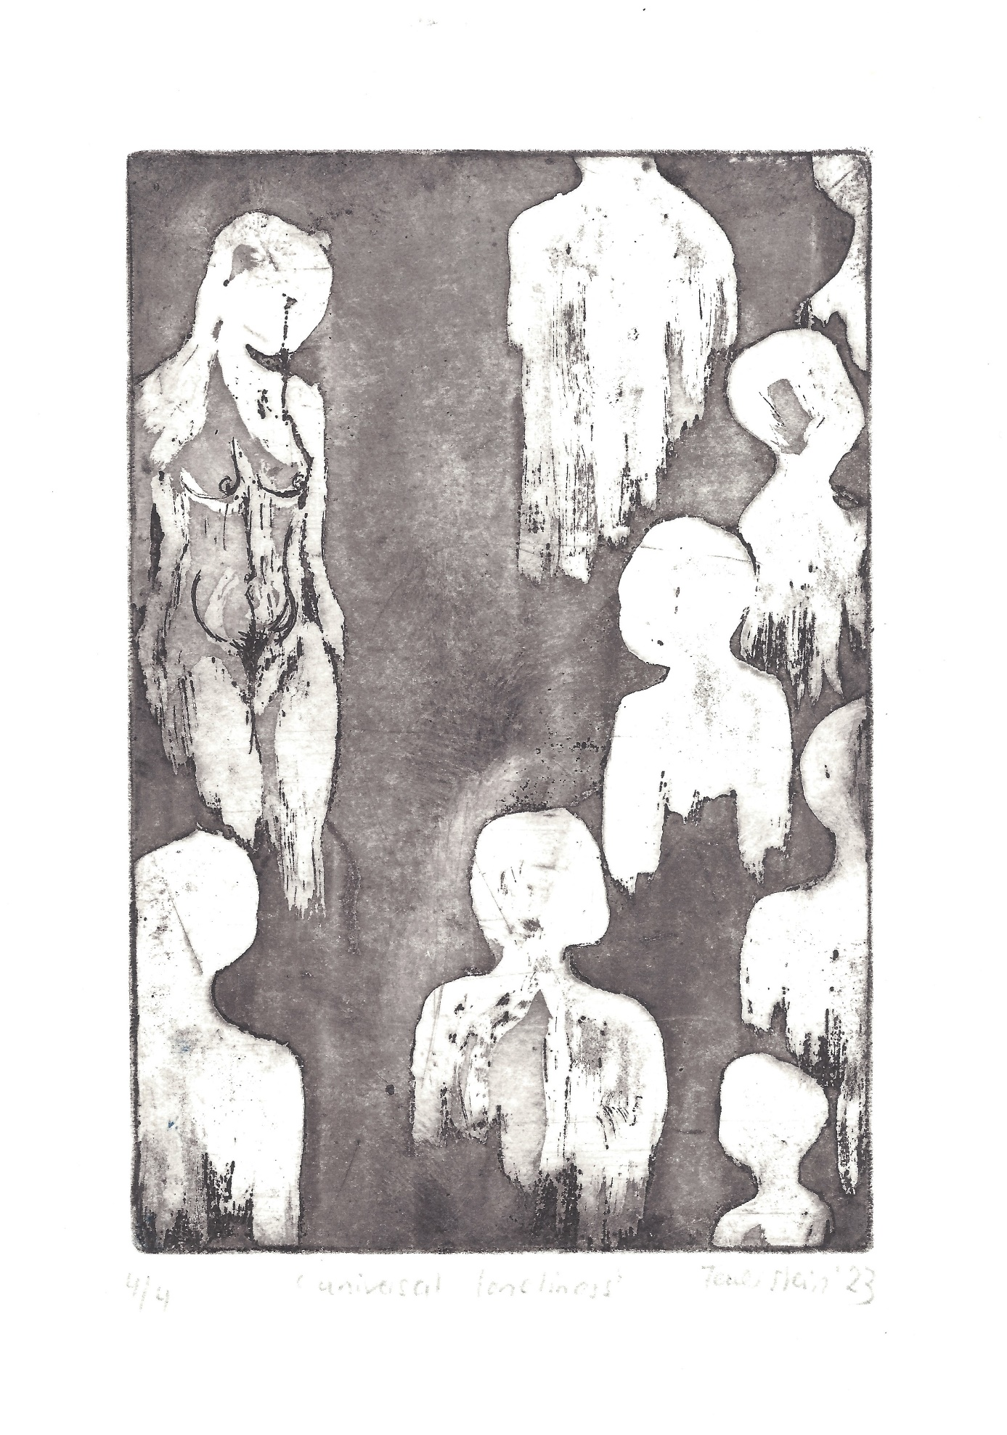

**[Image description: An abstract illustration of faceless figures on a greyscale background with a detailed drawing of a nude female body.]**

**[Image description: An abstract watercolour painting using dark blue and red with a series of eyes and wiggly arms. The words dispersed around the painting are ‘trapped’, ‘we all want a sense of togetherness’, ‘belonging’, ‘how can meet people’ and ‘I’m being noticed for everything I’m not’.]**

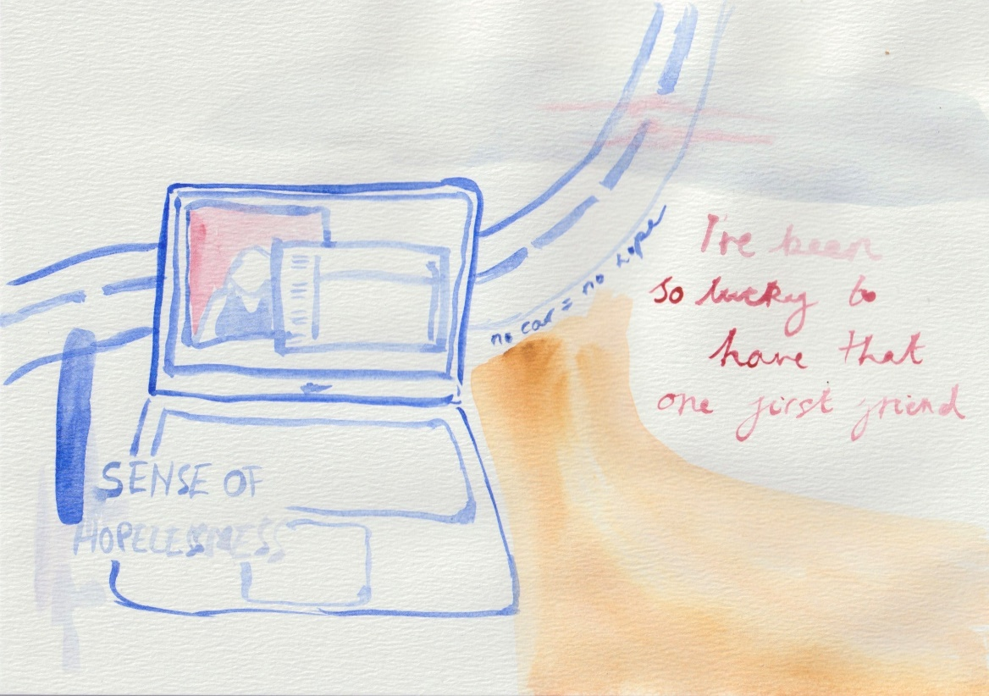

**[Image description: An abstract watercolour painting, in same style as the previous image, showing an open laptop. The colours of the lines are blue and yellow and the words are red and blue, which read ‘sense of hopelessness’, ‘no car = no hope’, ‘I’ve been so lucky to have that one first friend’.]**

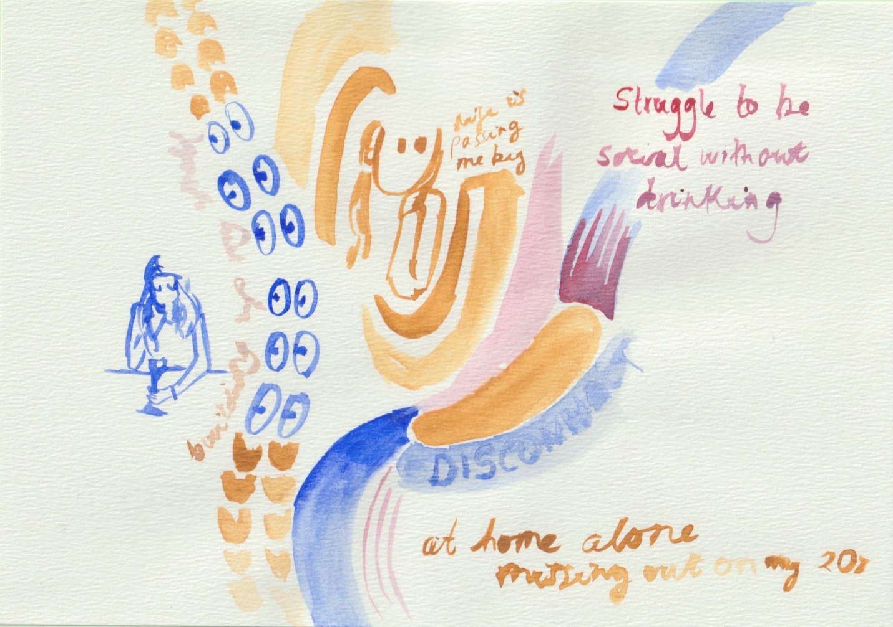

**[Image description: An abstract watercolour painting, in same style as the previous images, with the figure of a woman sat at a table holding a glass and a series of eyes. The colours used are blue, red and yellow and the words read ‘life is passing me by’, ‘struggle to be social without drinking’, ‘at home alone missing out on my 20’s’, ‘disconnect’ and ‘building up my world’.]**