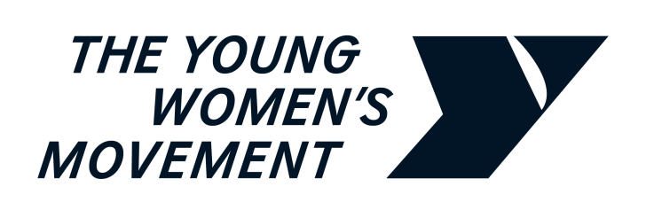￼

**Committee Call for Evidence on the Gender Representation on Public Boards (Amendment) Scotland Bill:**   
**Consultation Response from The Young Women’s Movement**

19 January 2024

**The Young Women’s Movement** is Scotland’s national organisation for young women’s feminist leadership and collective action against gender inequality. We value the power, and recognise the necessity, of working both intersectionally and intergenerationally to achieve change. Young women, girls and non-binary people who recognise themselves within this movement are at the heart of everything we do by participating, co-designing and leading our research, campaigns and programmes.

**This Bill will update the statute book by removing the definition of "woman" from section 2 of the Gender Representation on Public Boards (Scotland) Act 2018. This change is in line with the Court of Session ruling.**

**Do you have any views on this proposal?**

The Young Women’s Movement **supports the Gender Representation on Public Boards (Amendment) (Scotland) Bill because it simply confirms on paper the change to the Gender Representation on Public Boards (Scotland) Act 2018 that the Court of Session made in 2022. We supported the original 2018 Act as we believe that improving representation and equality for all women is vitally important, and we were pleased that the Scottish Parliament passed a law to improve women’s representation on Scottish Public Boards.**

**We supported the Scottish Parliament’s original definition of woman in the 2018 Act – a definition that was introduced by an amendment at stage 2, which was supported and endorsed by MSP members of the Equalities Committee across every party at Holyrood – as we believe that trans women** who have transitioned and are permanently living as women should be counted as women when it comes to positive action measures.

**As an intersectional feminist organisation,** we want our board meetings, programmes and campaigns to include all women. We welcome women of different races, different religions, disabled women, lesbian and bisexual women, and transgender women. We do not regard trans equality and women’s equality to contradict or be in competition with each other. As an organisation, we are enriched by the trans young women and girls who have added to our movement through their support, through volunteering, and as staff members.

**We were disappointed when the Court of Session ruled that including a fully trans-inclusive definition of woman in the Act was outwith the competence of the Scottish Parliament.** Nonetheless, we understand why this new Bill has been introduced as it simply confirms in the wording of the 2018 Act the change that has already been made by the Court of Session ruling in February 2022.

We believe it is important to highlight that the Court of Session did not rule on whether the Scottish Parliament’s original policy choice to include trans women without gender recognition certificates within the law was the right or wrong thing to do. Instead, it ruled that the Scottish Parliament could not include this definition within their legislative competence. We agree with the Scottish Government’s Equality Impact Assessment of the new Bill – that this change will have no negative impact on trans people, as it simply reflects the decision of the Court, which has already removed the definition in law.

It is our understanding that the Bill is the only way to remove from the statute book the definition at section 2 of the Gender Representation on Public Boards (Scotland) Act 2018. We therefore support the Bill. Going forward, **we urge politicians from across the political spectrum to reiterate their commitment to advancing gender equality and trans rights in Scotland.**

**FOR FURTHER INFORMATION**

Contact: Dr Rebecca Mason, Research and Policy Lead, The Young Women’s Movement   
Email: [rebecca@youngwomenscot.org](mailto:rebecca@youngwomenscot.org)

**ABOUT US**

The Young Women’s Movement is Scotland’s national organisation for young women’s feminist leadership and collective action against gender inequality. We value the power, and recognise the necessity, of working both intersectionally and intergenerationally to achieve change. Young women, girls and non-binary people who recognise themselves within this movement are at the heart of everything we do by participating, co-designing and leading our research, campaigns and programmes.