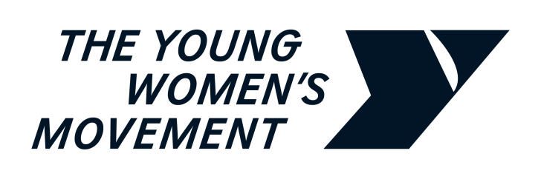

**The Young Women’s Movement Parliamentary Briefing:**   
**Women’s Inclusion in the Workplace**

**Thursday 7th March 2024**

***Parliamentary briefing for the Scottish Government Debate on International Women’s Day***

**BACKGROUND**

The Young Women’s Movement is Scotland’s national organisation for young women’s feminist leadership and collective action against gender inequality. Our vision is a fairer Scotland where young women and girls are meaningfully heard, valued and supported to lead collective action and enact transformational change throughout society, systems and structures.

**RESEARCH**

Our research, programmes and events are imagined and led by young women, for young women. The below analysis is taken from our Workplace Equality Fund project, Young Women Code, conducted in partnership with CodeClan, between March 2022 and March 2024[1].

**SUMMARY**

Young Women Code is a project funded by the Workplace Equality Fund, which contributes to ending gender disparity in the digital technology sector in Scotland. Women are hugely underrepresented in the digital tech sector; in Scotland, only 23% of the digital technology workforce are women. This sector can be challenging for young women to enter and progress in due to stereotypes that are built from a young age of STEM being ‘for boys’, which can push young women away from continuing their learning and entering these careers. The perception, and sometimes reality, of ‘tech bro’ culture being present in these organisations, can also act as a deterrent.

*“Young Women Code has actually had a really positive impact on my career [...] participating in the project showed me just how much of an impact I can make as a woman in the tech industry.” [training participant]*

Phase one, [an in-depth review](https://www.youngwomenscot.org/young-women-code) conducted in partnership with digital skills academy CodeClan, ran from 2022-23. This review found that:

* Women are **more likely** to sign up to **part-time** **technology courses** than men[2], primarily due to caring responsibilities and additional working commitments;
* **Women reported feeling “*measured by a different standard*” to male peers** in the tech job market;
* From the dropout data available, women students were **over three times as likely** (6%) than men students (2%) to withdraw from courses.

*“I think talking about how society is set up in such a way that women are disadvantaged at every turn [...] all the many ways this manifests was a really good way to draw attention to what male privilege really means.” [training participant]*

**BARRIERS TO YOUNG WOMEN IN THE TECH SECTOR**

* Due to women having disproportionate caring responsibilities, women tend to value **flexible working options**, such as hybrid and flexible start/end times, that support them to balance their working lives.
* Young women being **patronised/their knowledge being undermined** or others assuming a low level of understanding, because of their gender (and age). Because of assumptions around women in tech, women can be pushed away from roles where their skills are not valued or respected.
* Statutory **maternity leave is insufficient.** Only some tech organisations offer equal maternity and paternity leave, or the option to be flexible with these.

**BENEFITS OF MORE INCLUSIVE WORKING PRACTICES**

Our recommendations benefited more than just young women in the workplace:

* Flexible working arrangements can benefit anyone in a workplace and have particularly intersectional impacts, especially on those who require reasonable adjustments to their working arrangements;
* Improving parental leave benefits all parents, but also fans out benefit for the wider population, by supporting all parents to better participate in their children’s lives;
* There are huge benefits to workplace wellbeing when inclusion is promoted; the business/organisation itself benefits, as there is research that demonstrates that [a more diverse workforce is better for business.](https://www.breathehr.com/en-gb/blog/topic/business-leadership/8-benefits-of-encouraging-diversity-in-the-workplace)

*“I wouldn't have had such open discussions on these kinds of topics with them so hearing their opinions was really insightful.” [training participant]*

**CONCLUSION**

* **Workplace culture** is essential; inclusive working policies go hand-in-hand with an inclusive culture. Many organisations need external support to begin to build up an actively inclusive workplace culture, though it is often essential to deliver a business case to their Boards.

*We ask the Scottish Government to support organisations to deliver free gender inclusion training, like the Young Women Code programme, through direct funding, to support smaller organisations to receive this essential support. This should be co-created with young women so that the training provides support that is relevant and helpful to their needs within the workplace.*

* More focus should be given to **intake and retention** of young women within the tech workforce. Reduced funding for training academies like CodeClan means that there are fewer inclusive options for young women to train in tech, outside of the university system. These academies should provide flexible, funded places on their programmes, to better enable young women’s participation.  
    
  *We ask the Scottish Government to commit to supporting training academies like the former CodeClan to provide bursaries to facilitate young women’s participation in training courses. We also ask that they support organisations to provide mentorship programmes, to increase both intake and retention of young women within the tech workplace.*

**FOR FURTHER INFORMATION**

Contact: Saffron Roberts, Research & Policy Coordinator, The Young Women’s Movement  
Email: Saffron@youngwomenscot.org

**ABOUT US**  
The Young Women’s Movement is Scotland’s national organisation for young women’s feminist leadership and collective action against gender inequality. We value the power, and recognise the necessity, of working both intersectionally and intergenerationally to achieve change. Young women, girls and non-binary people who recognise themselves within this movement are at the heart of everything we do by participating, co-designing and leading our research and programmes.

1. Young Women Code, 2023, <https://www.youngwomenscot.org/young-women-code>   
   Note: CodeClan have since liquidated.
2. The part-time Software Development course had twice as many women as any other course (CodeClan, 2022)