YOUNG WOMEN CODE

Contents

Review of CodeClan 1

Approach 2

Students at CodeClan 2

Staff at CodeClan 2

Going Further at CodeClan 3

Who works with CodeClan? 3

Conclusions 4

Key Recommendations 4

Thank you 7

# Review of CodeClan

The Young Women’s Movement and CodeClan have collaborated to identify, address and reduce the intersecting barriers and challenges facing women entering and progressing within the digital technology sector.

Women are hugely underrepresented in the tech sector; [in Scotland, only 23% of the digital technology workforce are women.](https://www.scotlandis.com/insights/diversity-and-inclusion/)

This review and accompanying recommendations have been conducted with an intersectional and feminist lens to shine a light on the ways CodeClan could consider evolving to better meet the needs of young women in their training programmes and their staff team. This review and accompanying recommendations are useful for all organisations wishing to make their workplaces more inclusive and supportive of young women.

A huge thank you to our interviewees and working group members, without whom this review would not have been possible.

## Approach

A review of CodeClan’s data and policies, a working group of CodeClan staff, students and alumni, interviews with staff members, and a questionnaire were conducted between November 2022 and February 2023. The information collected that informs this review spans 2019-2022.

## Students at CodeClan

* Caring responsibilities, which tend to fall on women, have a huge impact on women’s ability to fully participate in courses, meaning there is real value in the part-time course for women.
* There needs to be a more streamlined structure for support, extensions and means of student aftercare to ensure everyone gets equal and fair treatment.
* Students value funded places and suggest that CodeClan lower the cost of courses or offer more cost-of-living support for students.
* Gendered ‘norms’ around STEM create a stigma that pushes women away from tech.
* Multiple women participants discussed entering the job market and feeling they were being “measured by a different standard” to their male peers.
* Young women wanted more support with their ‘next steps’ after taking part in CodeClan training.

## Staff at CodeClan

* Staff are unsatisfied with the statutory Maternity and Paternity Leave policies and note that this is often a factor for people leaving CodeClan. The new Exec Team at CodeClan are looking at improving Maternity and Paternity Leave policies as a priority, as a result.
* Staff members felt encouraged by senior leaders at CodeClan being women.
* CodeClan have a policy committing to training certain staff in equal opportunities.

## Going Further at CodeClan

* Working group participants suggested having a Parent Support Network or Family Day to help mitigate the barriers faced by parent-learners.
* An Ethnic Minority Support Group for staff and students was suggested to help get their voices heard and issues resolved.
* Students and staff alike value and want more diverse representation at CodeClan, including students wanting to be taught by more women.

## Who works with CodeClan?

* CodeClan's office staff were 39% men and 61% women, whilst the teaching staff were 78% men and 22% women, with women working in largely supporting roles.

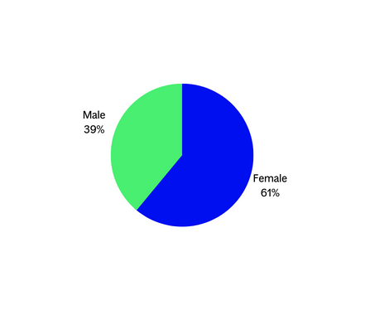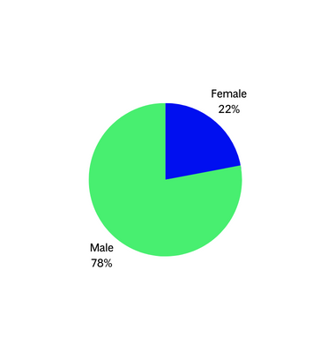

[Pie chart left depicting 39% male, 61% female office staff]

[Pie chart right depicting 78% male, 22% female teaching staff]

* The Executive Team were all women.
* Students on the adult courses were made up of only 27% female students.
* The only course with more than 27% women was the Part-time Software Development course, which had 58% female students; the part-time course is currently on hold.
* From the dropout data available, female students were over three times as likely (6%) than male students (2%) to withdraw from courses.

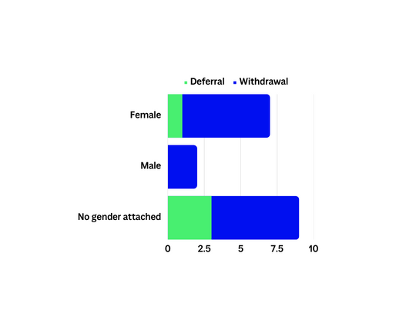

[Graph depicting student withdrawal and deferral rates, by gender]

* Equate Scotland run a popular funded course alongside CodeClan and report that women are interested in data jobs due to the flexibility of the hours and working arrangements, and the high pay.

## Conclusions

* Research suggests that women value flexible, remote, and part-time working opportunities, as well as mentorship.
* Office staff have a positive experience of CodeClan’s working culture and flexible working policies, whereas teaching staff do not have the same flexibility.
* CodeClan have already begun implementing some preliminary recommendations, such as increasing demographic data collection.

# Key Recommendations

The following recommendations are made by The Young Women’s Movement alongside the Young Women Code working group, utilising our expert intersectional feminist lens and their varied experiences and perspectives. These recommendations vary in their implementation timescales and are all suggestions on how CodeClan could begin to develop and improve upon their existing inclusion strategies. Each recommendation is open to development and discussion on how it could be implemented.

1. Make Equality Diversity Inclusion (EDI) training compulsory for all.

* This could be framed as part of the overarching culture of building respectful safe spaces and signposting boundaries.
* Regular refreshers should also be compulsory for staff.
* This training would happen as early as possible in the CodeClan journey, during staff and student onboarding.
* Have a named EDI Officer who staff and students can go to for support.

2. CodeClan Code of Conduct and Student & Staff Handbooks.

* Ensure these are regularly reviewed and updated, and that everyone always has access to them.

3. Use consistently inclusive language.

* Language around ‘soft’ and ‘hard’ skills needs to be de-gendered, e.g. into ‘tech-specific’ and ‘non-tech-specific' or ‘people’ skills.

4. Make the website more accessible to all users.

5. Advertising of jobs & courses.

* Develop/adapt job descriptions to make these more actively inclusive of flexible working options e.g. working from home, job-shares.
* Use fewer bullet-point essential criteria.
* Reduce use of masculine-coded language; increase open, welcoming language.
* Ensure interviewing panels have diverse representation where possible.
* Offer webinars for people to ask questions about job/course applications in advance to make it a more welcoming and open environment, especially for those with less experience or confidence.
* Provide clearer advertising and better offering of free taster sessions, including taster sessions exclusively for women.

6. Collect demographic data thoroughly & consistently.

* Collect demographic data at the application stage through a separate, anonymised EDI form and then again at onboarding.
* Make it clear what this information will be used for.

7. Moderation or establishment of group agreements/culture of respect & boundaries.

* Set out a zero-tolerance discrimination policy for staff/students in the Code of Conduct and detail clear consequences.
* Include setting out boundaries for more casual communication, such as Slack and email.
* Develop a culture that embraces accountability at the forefront – coming back to these agreements regularly, reviewing them after EDI training, returning to them when necessary.

8. More funding & support.

* Bursaries and funded places ringfenced for women – this could include childcare and cost of living bursaries.
* Ensure these are well signposted, easily accessible, and do not have complex and time-consuming application processes.

9. Develop & run more part-time courses.

* More hybrid part-time options would also be welcomed.
* An all-women cohort would be valuable for some groups of women who can’t, or would prefer not to, study alongside men.

10. Reduce the intensity of the workload.

* Provide a mid-course break week where nothing is scheduled. This break also enables staff to have set time off.
* Give the option of longer courses so that students have more learning time.

11. Streamlined support mechanisms & reasonable adjustments.

* There needs to be streamlined support options across the student population so that everyone is given equal opportunity access.
* Advertising adjustments as a given.
* Set up Parent and Ethnic Minority Support Groups (for staff and students).

12. Option to defer 6-months of post-graduation support.

* Some students may not be able to, or choose to, immediately gain employment in the tech sector – this should not hinder their ability to access the resources CodeClan offer all students post-graduation. Ensure this policy is clear so that all students understand what options are available to them from the outset.

13. Increase outreach to schools to help break stigmas early on and get more young women into the Youth Academy.

14. Develop CodeClan Women's Alumni Network.

15. HR department/consultant.

* Clarify what HR support is available and how staff can access confidential, unbiased support.

16. Flexible working options.

* Advertise positions with part-time/flexible/WFH/job-share options as a given.
* Ensure a welcoming approach to developing your working situation alongside your line manager.
* Clarity on exactly what ‘hybrid working’ means in job descriptions, e.g. ‘must be in the office x days a week/month.’
* Long-term, develop teacher roles and delivery methods to ensure everyone has flexible working options, and that these do not hinder progress.

17. Develop an improved Maternity Leave policy, with equal Paternity Leave.

# Thank you

Thank you to everyone who took part in this research, and shared honestly and vulnerably, without you this work would not have been possible.

To our working group members, who were critical friends at each stage of this project and supported us with our learning and recommendation development.

A huge thank you to CodeClan, for their partnership and consistent commitment to transparency and to learning.

Finally, thanks to the Workplace Equality Fund which provided funding for The Young Women’s Movement to dedicate staff time to this important research.

If you would like more information about the research, or to give feedback about this report, please contact [hello@youngwomenscot.org](mailto:hello@youngwomenscot.org)

@youngwomenscot

www.youngwomenscot.org